Silencing the Cosmic Ray – PAN 2012 Proposal
By Laurie Blevins, Matt Lewis, Andrew Cochrane and Lars Londot

Physics Justification
Cosmic ray “noise” is all around and going through us every second of every minute of every day. Even though cosmic rays are not a threat to us, they can be annoying to nuclear physicists that are conducting experiments with particle/radiation capture. Because of this fact, a new research facility is being built 1 mile underground to be able to shield all possible cosmic ray “noise” that may skew the results of the experimentation. http://dusel.org/ Since we cannot go underground that far here, we would like to explore the cosmic ray shielding effect of the concrete in the Shaw Parking Garage. We will measure the effect of each level of the garage down to the sub-ground level as to how much cosmic radiation is blocked.

Goals of the proposed experiment

Our goal is to determine how much energy can be absorbed by the air and concrete levels of a parking garage. If a material of density of 1 g/cm³ can absorb on average 1.5 MeV/ cm, we should expect concrete to absorb 3 times as much energy per cm. How effective concrete is as a shielding material and what thickness of concrete is effective is information that scientists could use when they need to find a place to conduct experiments that shields cosmic ray “noise”. Or, in layman’s terms, "the more thick stuff that is above me, the less I'll get zapped by cosmic rays"---anonymous.

Experimental Detail
To be measured:
Control- Background cosmic rays –
To measure the cosmic rays we will:
- Set up the CRD outside next to the Shaw parking garage on the lawn (fig 4) Scintillators will be oriented parallel to the ground.
* The placement of the CRD on the grass will reduce the chance of stray rays coming from any concrete below.
- 3 trials will be taken each lasting 3 minutes, the CRD will be set for coincidence and infinite count.

Concrete radiation –
To measure the amount of rays eminating from concrete we will:
- Set the CRD so the scintillators are parallel to the concrete wall on the top floor of the parking garage (fig. 5)
- 3 trials will be taken each lasting 3 minutes, the CRD will be set for coincidence and infinite count.

Amount of Shielding –
To measure the amount of shielding we will:
- Manually measure the thickness of the concrete floor in the stairwell between two floors. (fig 3) Assuming that each floor has a uniform thickness.
*if we cannot acquire the thickness in the stairwell we will use a side wall as an estimate.
- 3 trials will be taken each lasting 3 minutes, the CRD will be set for coincidence and infinite count.

Experimental Data –
To gather our experimental data we will:
- Set up the CRD in the SW corner of the garage on each floor of the garage. The CRD will be oriented so the scintillators are parallel to the floor.
- 3 trials will be taken each lasting 3 minutes, the CRD will be set for coincidence and infinite count.

Supplemental Information (Figures, Tables, References, etc., including one figure that depicts the layout of the experimental apparatus)

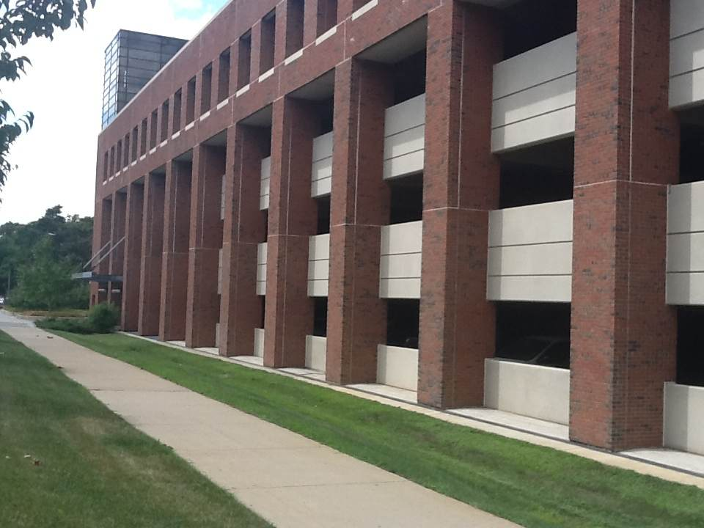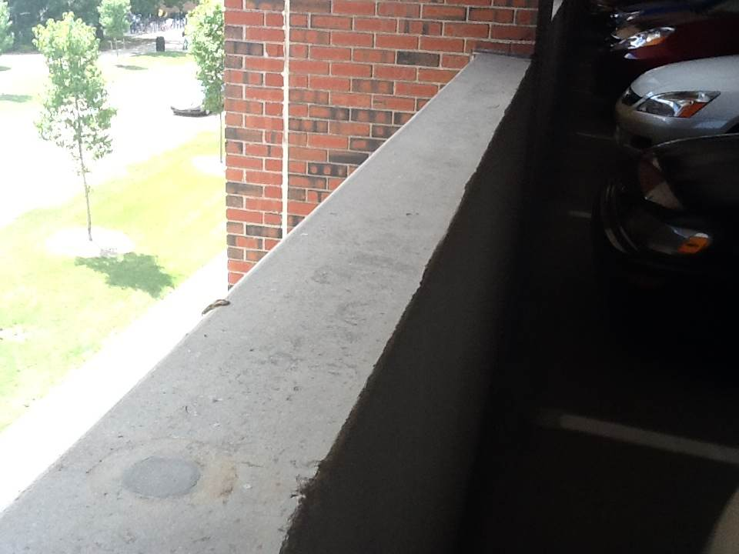
Fig. 1 – Shaw Road Parking Garage Fig. 2 – Concrete wall in Shaw Road P.G.

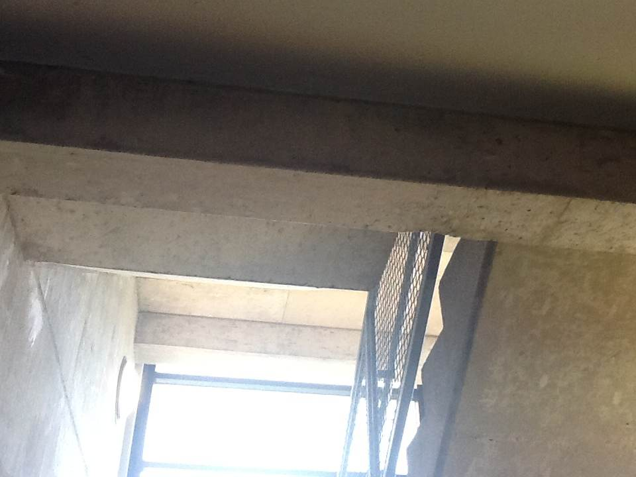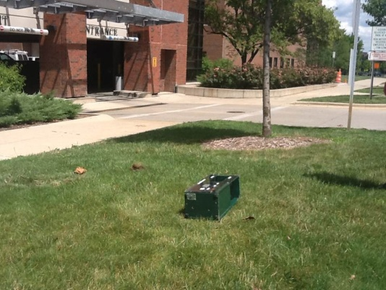

Fig. 3 – Stairwell in Shaw Road P.G. Fig. 4 – CRD Control Location
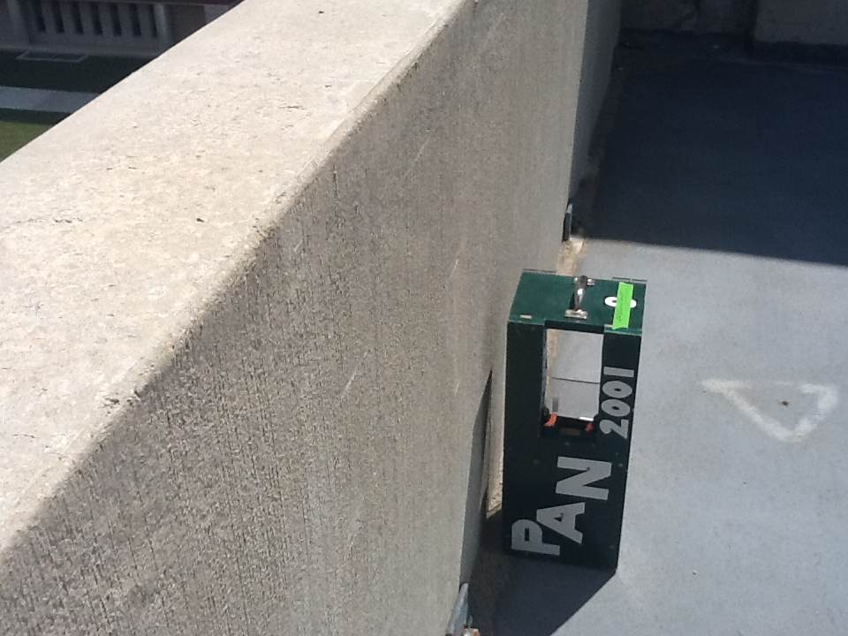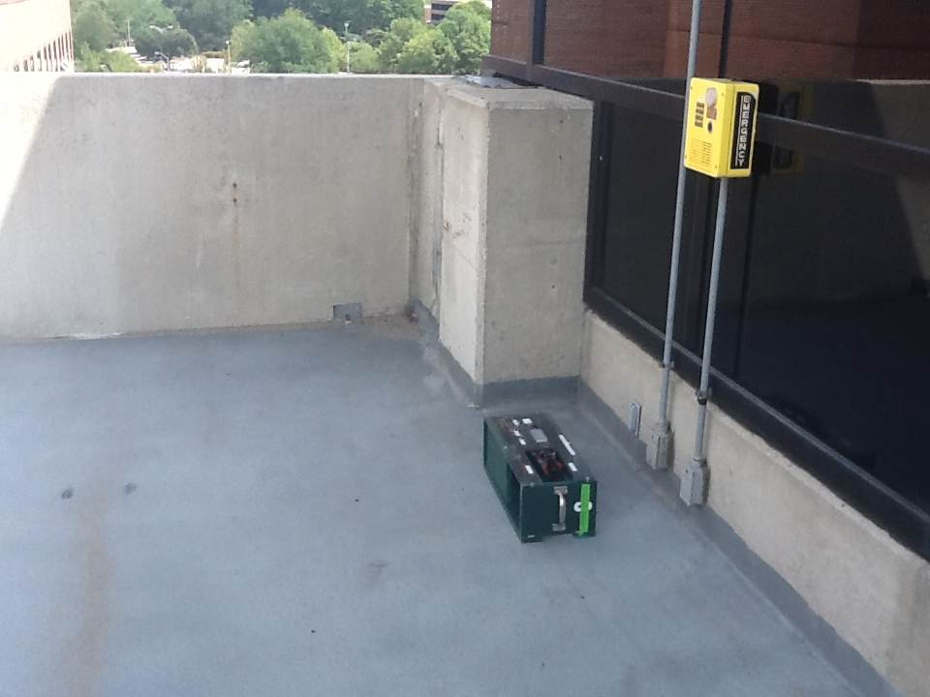
Fig. 5 – CRD Background Location Fig. 6 – CRD Location – Level 7

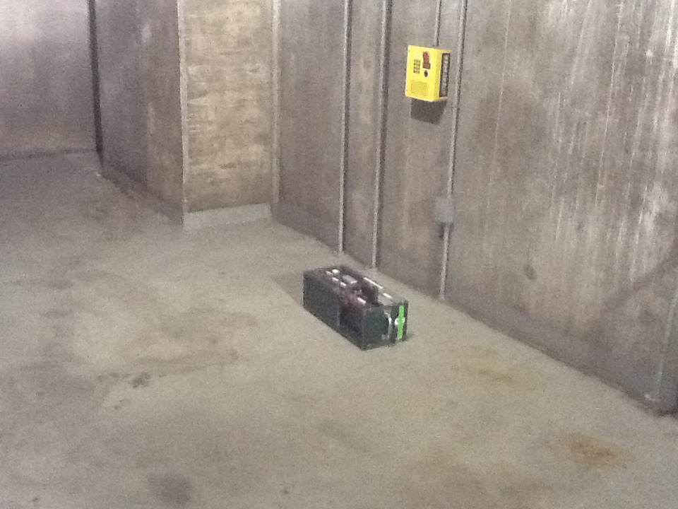
Fig. 7 – CRD Location – Level 1

