The Geiger Müller counter

Introduction

What is radioactivity?
Radioactivity is a property of certain atoms to spontaneously emit energy in the form of a particle or an electromagnetic wave. The nuclei of radioactive atoms are unstable and eventually stabilize by the emission of radiation. Radioactivity is measured in a unit equivalent to the number of disintegrations per second (dps) or disintegrations per minute (dpm). The SI unit for activity is the Becquerel (Bq) and one Becquerel is equal to one disintegration per second.
1 Bq = 1 dps = 60 dpm
Another unit of measure commonly used to denote the activity of a radioactive source is the Curie (Ci) where one Curie equals thirty seven billion disintegrations per second corresponding to the activity of 1 gram of radium (Ra).
1 Ci = 3.7x10¹⁰ dps = 2.2x10¹² dpm

What is the origin of Radiation?
Naturally occurring radioactive materials were created by:
- Formation of the universe or in stellar nucleosynthesis processes, producing some very long lived radioactive elements, such as uranium and thorium.
- The decay of some of these long lived materials into other radioactive materials like radium and radon.
- Fission products and their progeny (decay products), such as xenon, krypton, and iodine.
Man-made radioactive materials are most commonly made as fission products or from the decays of previously radioactive materials. Another method to manufacture radioactive materials is activation of non-radioactive materials when they are bombarded with neutrons (as we will do in this experiment), protons, other high energy particles, or high energy electromagnetic waves.

Types of radiation

The radiation one typically encounters is one of four types: alpha radiation, beta radiation, gamma radiation, and neutron radiation. These types of radiation are commonly encountered in everyday life, with sources being cosmic rays, bananas, concrete, and high altitude flight.
Alpha Radiation
Alpha radiation produces a heavy, very short-range particle and is actually an ejected helium nucleus. Some characteristics of alpha radiation are:
Most alpha radiation is not able to penetrate human skin.
Alpha-emitting materials can be harmful to humans if the materials are inhaled, swallowed, or absorbed through open wounds.
A thin-window Geiger-Mueller (GM) probe can detect the presence of alpha radiation.
Instruments cannot detect alpha radiation through even a thin layer of water, dust, paper, or other material, because alpha radiation is not penetrating.
Alpha radiation travels only a short distance (a few inches) in air, but is not an external hazard.
Alpha radiation is not able to penetrate clothing.
Examples of some alpha emitters: radium, radon, uranium, thorium.
Beta Radiation
Beta radiation is a light, short-range particle and is actually an ejected electron or positron. Some characteristics of beta radiation are:
Beta radiation may travel several feet in air and is moderately penetrating.
Beta radiation can penetrate human skin to the "germinal layer," where new skin cells are produced. If high levels of beta-emitting contaminants are allowed to remain on the skin for a prolonged period of time, they may cause skin injury.
Beta-emitting contaminants may be harmful if deposited internally.
Most beta emitters can be detected with a survey instrument and a thin-window GM probe (e.g., "pancake" type). Some beta emitters, however, produce very low-energy, poorly penetrating radiation that may be difficult or impossible to detect. Examples of these difficult-to-detect beta emitters are hydrogen-3 (tritium), carbon-14, and sulfur-35.
Clothing provides some protection against beta radiation.
Examples of some pure beta emitters: strontium-90, carbon-14, tritium, and sulfur-35. Note Potassium-40 is not a pure beta emitter, but predominantly beta decays and is in bananas.
Gamma and X Radiation
Gamma radiation and x rays are highly penetrating electromagnetic radiation. Some characteristics of these radiations are:
Gamma radiation or x rays are able to travel many feet in air and many inches in human tissue. They readily penetrate most materials and are sometimes called "penetrating" radiation.
Sealed radioactive sources and machines that emit gamma radiation and x rays respectively constitute an external hazard to humans.
Gamma radiation and x rays are electromagnetic radiation like visible light, radio waves, and ultraviolet light. These electromagnetic radiations differ only in the amount of energy they have. Gamma rays and x rays are the most energetic of these.
Dense materials are needed for shielding from gamma radiation. Clothing provides little shielding from penetrating radiation, but will prevent contamination of the skin by gamma-emitting radioactive materials.
Gamma radiation is easily detected by survey meters with a sodium iodide detector probe.
Gamma radiation and/or characteristic x rays frequently accompany the emission of alpha and beta radiation during radioactive decay.
Examples of some gamma emitters: iodine-131, cesium-137, cobalt-60, radium-226, and technetium-99m.

Is Radiation Dangerous?
Everyone on the face of the Earth receives background radiation from natural and man-made sources. The major natural sources include radon gas, cosmic radiation, terrestrial sources, and internal sources. The major man-made sources are medical/dental sources, consumer products, and other (nuclear bomb and disaster sources).
Radon gas is produced from the decay of uranium in the soil. The gas migrates up through the soil, attaches to dust particles, and is breathed into our lungs. The average yearly dose in the United States is about 200 mrem/yr. Cosmic rays are received from outer space and our sun. The amount of radiation depends on where you live, lower elevations receive less (~25 mrem/yr) while higher elevations receive more (~50 mrem/yr). Why? The average yearly dose in the United States is about 28 mrem/yr.
Terrestrial sources are sources that have been present from the formation of the Earth, like radium, uranium, and thorium. These sources are in the ground, rock, and building materials all around us. The average yearly dose in the United States is about 28 mrem/yr. The last naturally occurring background radiation source is due to the various chemicals in our own bodies. Potassium (⁴⁰K) is the major contributor and the average yearly dose in the United States is about 40 mrem/yr.
Radiation doses can also be received from man-made sources. The most common is the radiation from medical and dental x-rays. There is also radiation used to treat cancer patients. The average yearly dose in the United States is about 54 mrem/yr. There are small amounts of radiation in consumer products, such as smoke detectors, some luminous dial watches, and ceramic dishes (with an orange glaze). The average yearly dose in the United States is about 10 mrem/yr. The other man-made sources are fallout from nuclear bomb testing and usage, and from accidents at nuclear power plants such as Chernobyl or Fukushima. The average yearly dose in the United States is about 3 mrem/yr.
Adding up the naturally occurring and man-made sources, we receive on average about 360 mrem/yr of radioactivity exposure.

The Geiger-Müller Counter
Geiger-Müller (GM) counters were invented by H. Geiger and E.W. Müller in 1928, and are used to detect radioactive particles ( αand β) and rays (γ and x). A GM tube usually consists of an airtight metal cylinder closed at both ends and filled with a gas that is easily ionized (usually neon, argon, and halogen). One end consists of a “window” which is a thin material, mica, allowing the entrance of alpha particles. A wire, which runs lengthwise down the center of the tube, is positively charged with a relatively high voltage and acts as an anode. The tube acts as the cathode. The anode and cathode are connected to an electric circuit that maintains the high voltage between them.
When the radiation enters the GM tube, it will ionize some of the atoms of the gas. Due to the large electric field created between the anode and cathode, the resulting positive ions and negative electrons accelerate toward the cathode and anode, respectively. Electrons move or drift through the gas at a speed of about 10⁴ m/s, which is about 10⁴ microseconds after they are created, while the positive ions take a few milliseconds to travel to the cathode. As the electrons travel toward the anode they ionize other atoms, which produces a cascade of electrons called gas multiplication or a (Townsend) avalanche. The multiplication factor is typically 10⁶ to 10⁸. The resulting discharge current causes the voltage between the anode and cathode to drop. The counter (electric circuit) detects this voltage drop and recognizes it as a signal of a particle’s presence. There are additional discharges triggered by UV photons liberated in the ionization process that start avalanches away from the original ionization site.
These discharges are called Geiger-Müller discharges. These do not affect the performance as they are short-lived.
We know that Gamma-Radiation is deeply penetrating. How do we detect Gamma-Rays with a GM counter?

Experiment #1: Half-Life of ^{108,110}Ag
Objective
The students will measure the half-life ^{108,110}Ag.

Introduction
The decay of radioactive atoms occurs at a constant rate. The rate of decay is also a constant, fixed rate regardless of the amount of radioactive atoms present. That is because there are only two choices for each atom, decay or don’t decay. Thus, the amount of radioactive atoms we have on hand at any time is undergoing a consistent, continuous change.
The change in the number of radioactive atoms is a very orderly process. If we know the number of atoms present and their decay constant (probability of decay per unit time), then we can calculate how many atoms will remain at any future time. This can be written as the equation
$N\left(t\right)=N_{0}e^{-λt}$ (1)
Where N(t) is the number of radioactive atoms that will be present at time t, N₀ is the number of atoms present currently, λ is the decay constant, and t is the elapsed time. If the number of radioactive atoms remaining is plotted against time, a curve like the one shown in Figure 1 can be obtained. 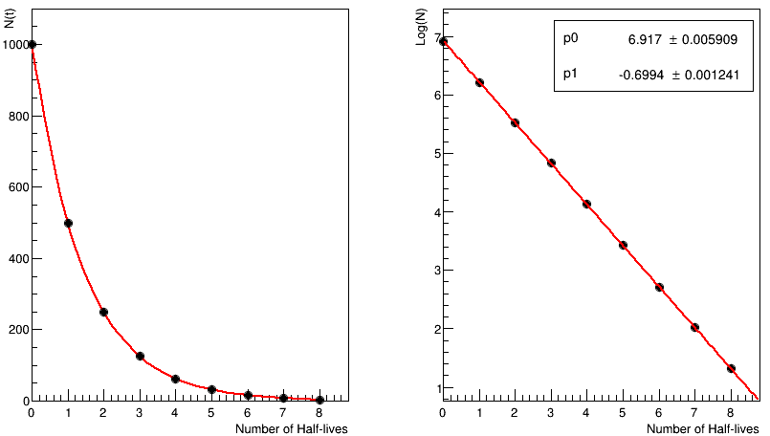
Figure 1: Left Panel: Exponential decay curve. Right panel: Logarithm of the activity vs time.
If we take the logarithm in Equation (1):
 | $$\ln{(N\left(t\right))}=\ln{(N_{0}e^{-λt})}$$ | (2)

And rearranging terms
 | $$\ln{(N\left(t\right))}=\ln{N_{0}-λt}$$ | (3)
This equation corresponds to a straight line whose slope is directly the decay constant λ (Right panel on Fig. 1)
A more common way of expressing the decay of radioactive atoms is the half-life (t_{1/2}). The half-life of a radioactive isotope is the time required for the disintegration of one-half of the atoms in the original sample. For example, if 1000 atoms were present at t = 0. At the end of one half-life, 500 atoms were present. At the end of two half-lives, 250 atoms were present, one-quarter of the original sample, and so on.
Since the observed activity of a sample as detected by a Geiger counter is proportional to the number of radioactive atoms, it is not necessary to know exactly how many atoms are present to determine either the half-life or the decay constant. Any quantity of sample providing a suitable activity may be used.

Procedure
- Prepare the Geiger counter station as outlined in the Appendix.
- The instructor will supply an activated Ag disk.
- Immediately place the disk directly under the G-M counter. Click Start in data studio, and take data for 15-20 minutes.
- Record the data to a file on disk or into a data table.
- Return the Ag disk to an instructor. Get another disk to take more data while you analyze the data you have already collected.

Data analysis
- Import or copy the data to an Excel spreadsheet (see appendix for help with Excel). The data you collected will be presented in two columns, one with the time and other with the counts registered on each time interval.
- Make a graph of number of Counts vs. Time. From this graph, you will be able to see the true exponential nature of the decay and also be able to estimate approximate half-life.
- Calculate the natural logarithm of the number of counts for each run. Use the LN function.
- Make a graph of Natural Log (Ln) of Counts vs. Time.
- The next task is to measure the slope of the decay curve of the longer lived isotope. To do this select two points near the end of the run and calculate their slope.
- Calculate the slope for two more sets of points, ranging from the end of the curve (in time), to near where you believe the faster decay to be more dominant.
- Use these slopes to calculate the half-life given the formula below.

$$-\left(slope\right)=λ=\frac{\ln{(2})}{t_{1/2}}$$

- Determine the average half-life measured.
- Using this information you can subtract the contribution from the long lived Ag isotope from the total number of decays observed, and in turn determine the half-life of the shorter lived Ag isotope.
- Create a new column where you will have the subtracted counts. These are calculated by the formula below. Note that $N_{ll0}$ (ll for longer lived, sl for shorter lived) can be determined from what we already know.
$$ln⁡(N-N_{ll0}e^{-λ_{ll}t})=\ln\left(N_{sl0}\right)-λ_{sl}t$$
- Make a graph of the Natural Log (LN) of subtracted counts versus time, and calculate the slope in the same manner as explained before (now focusing on the early part of the curve).
- To determine the error on the slopes, calculate the standard deviation using STDEV, where you pass the 3 slope values as the arguments.
- In order to calculate the error of the half-life, we have to propagate the error of the slope
$$σ_{t_{1/2}}=\frac{σ_{λ}}{λ}t_{1/2}$$
- Now, to find the number of σ’s that your results are away from the true values of t_{1/2} = 142 s and t_{1/2} = 24 s, we use the following equation
# of σ’s=$\left|\frac{measured-true}{σ_{t_{1/2}}}\right|$

What you measure is the difference between your result and the true value and then see how many standard deviations that is. The rule of thumb is that the result should be no more than 2σ’s away from the true value to be statistically likely to be accurate.

Post-lab questions
- Write your result with the error, i.e. 153 s ± 1 s. Is this result (statistically) good? (Recall that any value judgements must be justified.)
- How is the slope best determined? Why?
- How can the experiment be improved?

Nuclear Safety Guidelines
PLEASE READ CAREFULLY ALL OF THESE!! - All work with radioactive materials in the laboratory must be supervised by an instructor.
- Special care should always be taken to avoid unnecessary handling of the sources, contact with the skin, and close proximity of sources to the eyes.
- Eating, drinking, smoking, using cosmetics, and chewing gum are strictly forbidden.
- Protective gloves should be worn whenever an instructor or student is handling or transferring a radioactive liquid.
- When radioactive sources are not in use, they should be stored in an appropriately labeled container and kept in a place of limited access.
- A survey should be promptly conducted when suspicion that an area, clothing, or hands have been contaminated. A portable radiation counter is available. The radiation you are working with is low in intensity and has a short lifetime. Small spillage is not dangerous but should be cleaned up promptly.
- Should an accident occur, it should be reported immediately to the lab instructor.
- Upon completion of the experiments, sources are to be returned to their designated storage containers. No sources are to be removed from the laboratory.
- Everyone who any contact with the samples should thoroughly wash their hands before leaving the laboratory.
- Dispose of all waste in the designated radioactive container.
- Enjoy the experiments!

Appendix: Getting Started with the GM Setup
The following details how to properly set up the GM experiment.
Begin by opening the Windows XP virtual box.
Open the “192 Lab Files” folder. This contains the software necessary for analysis.
Select the “Half Life” folder. Inside will look like this.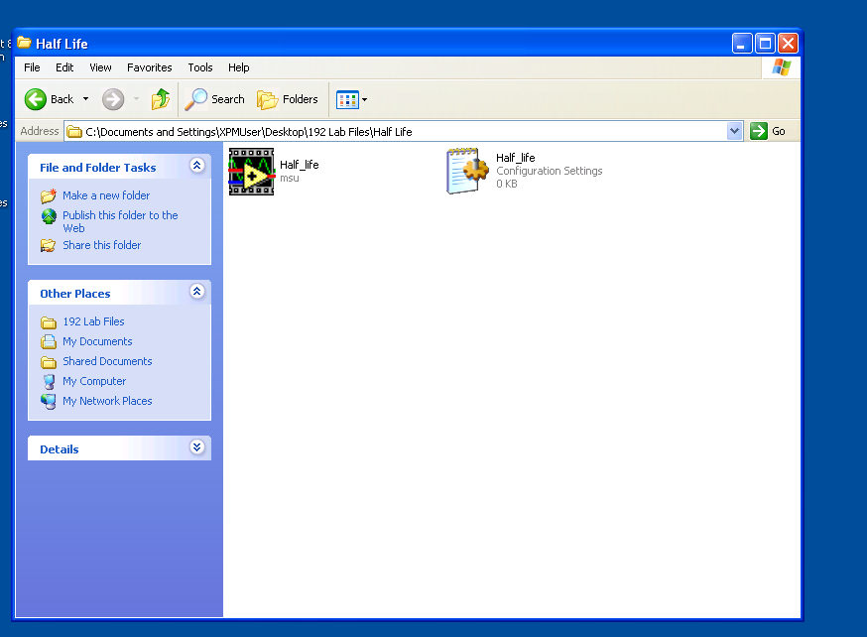
Select the “Half_life” program. While this is opening look at the top of the Virtual machine, and attach the unidentified USB device. Accept all things needed for the installation.
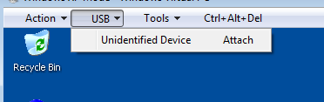
The Half_life program will bring up the following window. Set the GM voltage to 900 V, the Count Duration to 20 s, and select the highest COM value (will likely be COM4 – see below).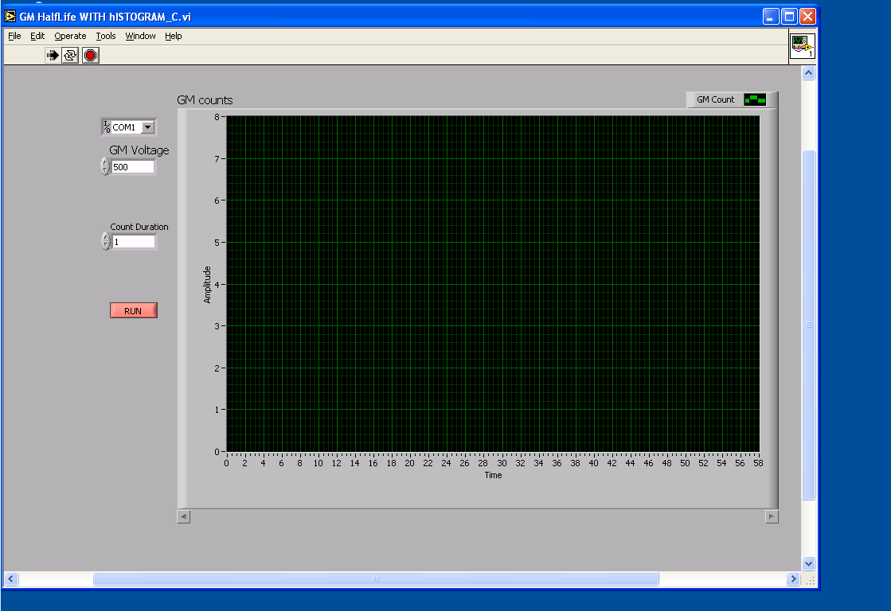
Note that the correct COM value will not show up until the USB device has been properly installed and attached.
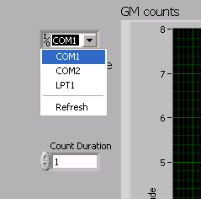
To begin recording data hit “RUN”. You will know when it is working. When a run is ended you will be prompted to name the data file. 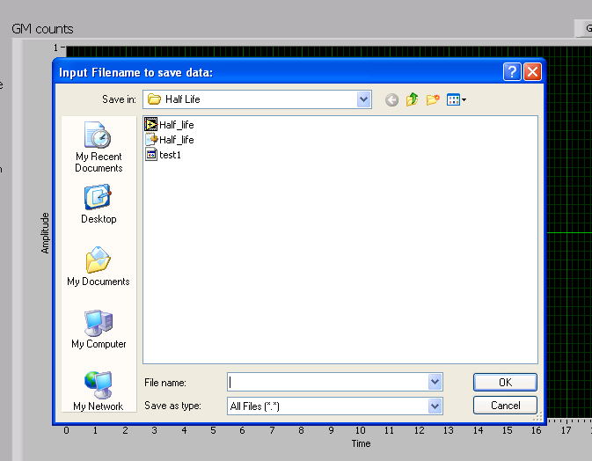
This file is now stored in the same folder that contains the Half_life program. This is where you will find it when you are ready to read it in Excel.

Appendix: Using Excel for Plotting data
The following tutorial includes basic instructions for using Microsoft Excel 2011for and how to make line (XY) graphs. This type of graph will allow us to show the exponential decay and extract the half-life of ^{108,110}Ag.

Scatter (XY) Graphs
The procedure is very straight forward. Use the mouse to highlight the data you want to plot. Then click the Insert tab. Then select in the Chart Section the Scatter option

When you click in the Chart type you want, Excel automatically creates a draft of the chart and it pastes it into the worksheet, like this:
If the data plotted is not what you want, right click and select “Select Data”. You can now remove the current data, and then Add a new set of data. 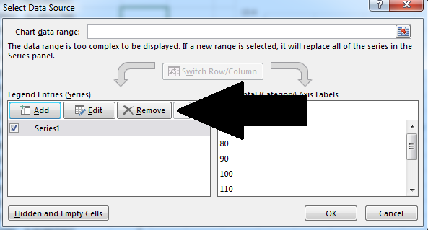
You can leave the name blank, and click on the button with the red arrow on it and then highlight the column with the data you want for the x and y values. For the first plot you are making the x values will be the time values, and the y values will be the number of counts.
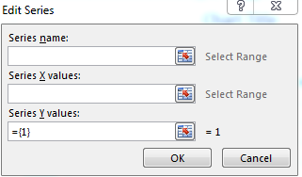
To add labels to the axis, legends, etc., click on the + on the right of the chart and click on any of the chart elements you want to add. You can edit each element by clicking on it.
To add the trend line, the procedure is the same as any other chart elements. You will have to choose which kind of trend line you want, and you can select to display the equation on the graph as well as the correlation factor R².
.

mrem (millirem) is a unit used for the equivalent dose of radiation.. These quantities are a complex weighted average of absorbed dose, which is a clear physical quantity measured in rads (Absorbed energy per mass unit).

