Weekly AT-TPC meeting
Thursday, March 18, 2010
9:30-10:30 am EST at Nuclear Conference Room
Attendees: Z. Chajecki, M. Ford, W. Lynch, W. Mittig, F. Montes, D. Suzuki, T. Tarnowsky, H. Wang, G. Westfall
- Field calculation (Fenando)
Fernando conducted an electric field simulation by using the code GARFIELD. The figure shows simulated field lines for a design wherein a series of ring electrodes with a 5-mm diameter are aligned with a 10-mm spacing both inside and outside of the field cage tube. The field inhomogeneity is as small as less than 1 per mil.
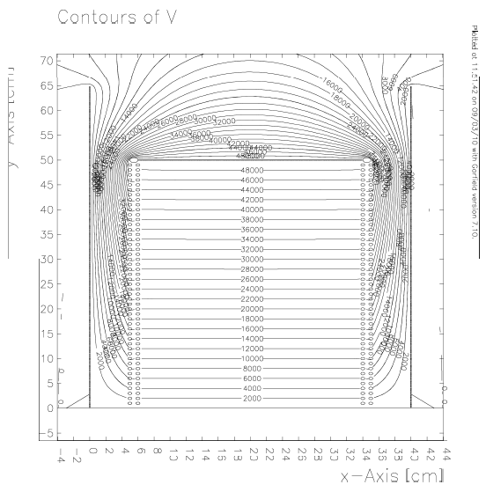
- Design of the test field cage (DS)
DS reported on discussions on the field cage design.

Required specifications
- Gas tight (in order to realize a gas insulation scheme)
- 50 kV at the cathode ( = 1 kV/cm)
Risks
- Sparking between the electrodes
- Permanent short on the tube surface
Ideas
- G10 tube + Ring electrodes
(+) Can avoid a sparking close to the tube surface
(-) How to fabricate rings?
(-) How to make a fixture?

- G10 tube + A circuit sheet with electrode stripes
(+) Easy to make a circuit sheet. Usually used in a large TPC for high energy physics
(-) Should avoid a bubble in between the tube and the sheet. It will inflate like a pup corn when we evacuate the chamber

- A stack of G10 rings and metal rings, glued together to form a body frame
(+) Easy to fabricate (Just cutting a tube of G10 and a metal).
(-) Sealing is not easy because of the large area to be glued.

- Resistive glass tube
(+) Just a single piece both for a body frame and electrodes.
(-) Could not find out a vendor for a large diameter tube 11”OD.
We have decided to do a test to investigate the mechanical aspect of the 1st option (G10 + ring). An acrylic tube with 10.5”O.D. and 24” length will be used for the body. The tube has already been purchased and stored at W105.
The design of a fixing jig of electrodes is under discussion. Three ideas are being considered:
- Screw
(+) Easy to fabricate, easy to assemble
(-) Sharp edges could be a point of discharge.
- Clip
(+) Easy to assemble
(-) Is there any vendor who can manufacture appropriate clips?

- Parallel plates
(+) Can be made in lab
(-) It will take a time to assembly because of a large number of pieces (at least 50 x 3 x 2 = 300)

To Do:
- Wolfi and DS will consider the design of fixing jig. Should discuss with John.
- Wolfi and DS will prepare and submit a work order or a purchase requisition for fabrication of ring electrodes.

- ZAP (Bill)
Bill reported on the GET video conference about a ZAP. The conference was held on Monday 15, 2010 among IRFU, CEA-Saclay, CENBG, RIKEN and NSCL (WM, WL and DS ).
ZAP is an intermediate board connecting between the chamber feed through and the AsAd board equipped with ASICs. ZAP provides two major functions. One is to have a discharge protection circuit prior to the AsAd board. The other is to provide a flexible connection of the AsAd board, depending on a specific geometry of the detector. Because of the latter function, the design and production of the ZAP is responsible for each laboratory.
Concerning the protection circuit, two options are under discussed. The document is on eDoc. The first option has a pair of diodes on the ZAP board. It clips a fast transient voltage. Question of Wolfi and Bill: Why do we have to bias one of the diodes?

The second option uses a resistance in place of the diodes, which could be a source of noise. The resistance limits the current entering the ASIC when the discharge occurs.

In addition to the protection circuit, we take into account the following items for the design:
- Individual bias on anode segments. This capability is needed to realize different gains for individual segments. Question: How many different voltages are needed?
- Shorter circuit is better in terms of input capacitance.
To Do:
- Mike will make a circuit design for the test bench, which incorporates an individual bias for the strips. We should discuss the circuit scheme before making a detailed drawing.
- Bill will ask about why we need to bias one of the diodes.

- Micromegas capacitance (Wolfi)
Wolfi reported about the capacitance of the Micromegas. Jim Vincent has measured the capacitance of the Micromegas (10 x 10 cm²). The measured value between a strip (0.5 x 10cm²) and the mesh plane was 100 pF, which deviates from Wolfi’s estimate by a factor of 2. Bill commented that it is not easy to measure a capacitance because of a finite lead capacitance.
To Do:
- Mike will re-measure and calculate the capacitance.

- Scroll pump (Fernando/DS)
We discuss the purchasing of a scroll pump. Currently we use an oil-sealed mechanical pump, which is a source of contamination. Ana and Fernando have already chosen Edward XDS10 for the new gas handling system of the AT-TPC. This scroll pump can be used for the test bench and Prototype development.

To Do:
- Fernando or Ana will proceed with a purchase order.

