Rough Estimate of Gas-handling Components Required: Short list
Compressor: Contacted KNF 30 Sept. ‘12
FORMERLY: GAST MAA Diaphragm, Two-Stage ($386.90 for 1)
Mass Flow Controller: MKS πMFC PFC-50 or PFC-60 Quote Requested (Option2 price: $6672 for 3)
Purifier/Filter: Systems Specialties Gaskleen II Purifier ($3320 for 2)
Pump: Edwards XDS10 ($6,257 for 1)
Mixing Baffle: McMaster-Carr 12 blade Inline Pipe Mixer ($350-$880 for 1)
Molecular Sieve: Scientific Instrument Services MT-752K Adsorption Trap ($325 for 1)
Cold-Trap: NSCL can build one, according to J.Yurkon, but I haven’t contacted Jay Pline
FORMERLY: Scientific Instrument Services LN2 Cold-Trap ($1060 for 2)
Regulators: : McMaster-Carr Gas Pressure Control Regulator CGA 7897A16&17 ($1325.80 for 5)
Pressure Transducers: MKS 622B 13TDE Baratron ($2208 for 2)
Differential Pressure Transducers: MKS 226A(21MGAGAFB1T1) ($1376 for 2)
Automated Valves: Swagelok IGC-II Pneumatic-Actuated Low-Pressure Valve
FORMERLY Kurt J. Lesker Bellows Sealed Angle Valve (SA0100EVQF) ($2180 for 5)
Manual Valves: Swagelok IGC-II Toggle-actuated Low-Pressure Valve
FORMERLY Kurt J. Lesker Bellows Sealed Angle Valve (SA0100MVQF) ($3360 for 12)
Storage Tank: McMaster-Carr High Pressure Inert Service HP80 (7822A14) ($303.63 for 1)
Gas Analyzer: MKS Cirrus 2 continuous gas analyzer ($44K for 1)
Or Extrel MAX300 LG Gas Analyzer ($66K for 1)
Heat Exchanger: Necessary? If so, Exergy Sanitary 17 Series ($1800 for 1)
Ballast Tank: McMaster-Carr ASME-Code Horizontal Pressure Tank 9426K14 ($1148.45 for 1)
Total Price, minus gas analyzer & minus connecting components: $31,917
…with gas analyzer: $76-98,000

Rough Estimate of Gas-Handling Components Required: Full List of Options
Compressor
Option1: Cal Supply Company Low Pressure Oil Free Rotary Claw Compressor
- Operates at 0-30psi
- Dry-running
- Requested more information (March 13) as it’s not clear this compressor can be used with recirculating gas
  - Response: What we want is too small. Directed me to GAST
Option2: Fluitron Inc Unsure of model
- Dry-running
- Leakage (using metal seals): 1e-9 scc/s = 4e-9 standard liters per hour
- Requested more information (March 13) as only general qualities of their compressor models are quoted
  - Response: 1 stage unit can take 0.2 atm (160 torr) input at 0PSIG output for $14,000; 2-stage unit can take 0.1 atm input at 0PSIG output for $28,000. No model # quoted
- Cost: Ana’s spreadsheet (no model quoted) says $15,300 (including metal seals)
Option3: GAST (gastmfg.com)
- Need to contact these guys to see what they think is best. First need to find out a likely pressure drop across other components.
- Requested manual on their line of compressors:
http://www.gastmfg.com/catalogs/rotaryvane_catalog.pdf
http://www.gastmfg.com/catalogs/diaphragm_catalog.pdf

- Closest to meeting our needs: (Unsure about DAA & 15D(DC)
  - Two-Stage MAA Diaphragm:3.5bar max press, 48mbar min pres, max flow 2.4m3/hr; Noise: 69-83dB (85dB for 8hrs a day is max allowed w/out ear plugs)
  - $386.90
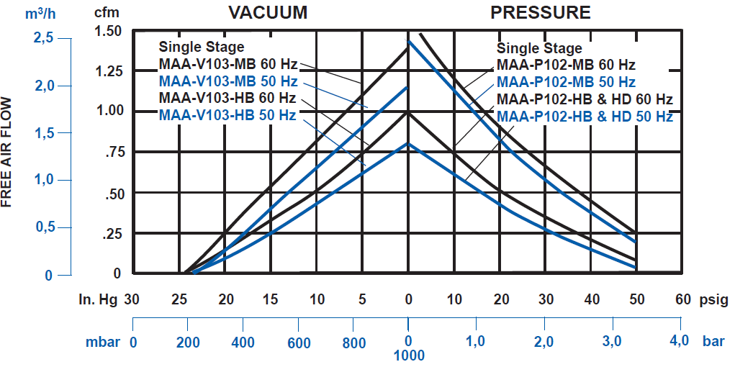
  - DOA Diaphragm? ….didn’t show-up on search by specifications we require
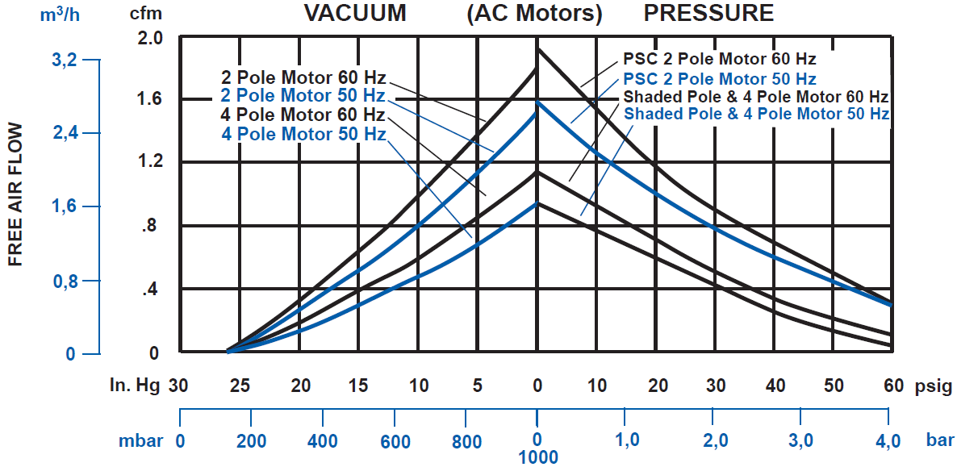

Mass Flow Controllers
Option1: MKS Type 1479A Metal-Sealed
- Analog control
- Full scale range anywhere from 10sccm to 20slm
- Accuracy:±1% Full Scale
- Repeatability ±0.2% Full Scale
- Leak Rate: <1e-10 scc/sec = 4e-10 standard liters per hour
- Calibrated for a SPECIFIC GAS
- “Normal Operation Pressure Differential: 10-40psig” ?? (Contacted MKS about this)
- Two year warranty
- Cost: The Kurt J. Lesker catalog quotes the price at $1,594 + $300 for surface mount seal + $330 for the electrical connector (RS 485) $2224 each
Option2: MKS πMFC Model PFC-50 or PFC-60
- 50: “Multi-Range”
- 60: “Pressure Insensitive”
- Digital or Analog Control
- Calibrated for a specific gas, but the current gas being used can be programmed in
- Otherwise, specifications same as for 1479A
- Contacted MKS (March 13) for comparison between above 3 devices & cost estimate
  - Reminder sent april 8th. Received reply that they’d “get back to me” on Mar 13
Purifiers
Option1: Matheson Tri-Gas PUR-Gas Cartridge Purifier System
- Max Flow rate is 3 liters per minute, so perhaps not compatible with our system
- Clean gases to 99.9999% purity
- Cartridge installed on a base-plate so as to be replaceable (without tools)
  - Check-valve closes upon cartridge replacement
  - 1,2,or 3 cartridge base plates available
- Can either get Moisture, Oxygen, Hydrocarbon, a combination of the two, or all three
- Color indicator for purity for Moisture & Oxygen purifiers
- Seems to assume inert carrier gas. Not sure if this is for example, or the only kind of gases they recommend using this purifier system with
- See pgs. 333-336 Matheson Tri-Gas manual

Option2: Matheson Tri-Gas PUR-Gas In-Line Purifier System
- Max flow rate is 25 liters per minute
- Clean gases to 99.9999% purity
- Can either get Moisture, Oxygen, Hydrocarbon, a combination of the two, or all three
- H₂O capacity of 6grams, O₂ capacity of 1000grams, & Hydrocarbon capacity of 12 grams
  - Estimated life-span: >2 years
  - Higher capacity for single in-line purifiers
- Seems to assume He carrier gas. Not sure if this is for example or really the only gas they recommend using this purifier system with
- Proper orientation is Vertical
- See pgs. 337-339 Matheson Tri-Gas manual
Option3: Entegris Inert Gas Purifier
- Meant for: N₂, He, Ne, Kr, Ar, Xe, Halocarbons, Light Hydrocarbons
- Purity: <100ppb H₂, CO, CO₂; <100ppt H₂O O₂
  - Assumes <10ppm concentration of contaminants; <1ppm moisture
- Leakage: 1e-9 scc/sec = 4e-9 slm
- Must operate above 1atm, but perhaps this is ok, as we could purposely have a pressure-drop across the mass flow controller & the mixing baffle will have some pressure drop
- ~1year estimated lifetime at nominal flow rate
- Several models available for various flow ranges; pressure drops vary for each
  - 70KF: 3slm max, 1slm nominal; with 0.7psid pressure drop
  - 100KF: 20slm max, 2slm nominal; with 4psid pressure drop
  - 300KF: 50slm max, 7slm nominal; with 5psid pressure drop
    - This would be my choice. Quote requested 8 April ‘12
Option4: NuPure UltraPure PF Series Point-of-Use UHP Gas Purifier Model 600PF
- Max Flow (at 150psig): 30slm
- Liftetime: 1 year at nominal flow of 6slm
- Leak Rate: <2e-9 scc/s = 8e-9 slm for He
- Fittings: ¼”” VCR
- Used for flow gases: Ar, Ar/CH₄, He, CH₄, Ne, CF₄, Xe, Kr, SF₆,N₂
- To remove impurities: H₂O, O₂, CO to <10ppb
- Filters contaminants above size: 0.004micron
- Requested (Mar 14) quote & pressure-drop information
Option 5: Systems Specialties Gaskleen II Purifier
- Inert Gases: GLP2INPVMM4; Flammable: GLP2SIPVMM4
- Removes H₂O,O₂,CO₂,CO to <1ppb
- 1x10⁹ retention of particles >0.003μm up to 5slpm
- $1660 each
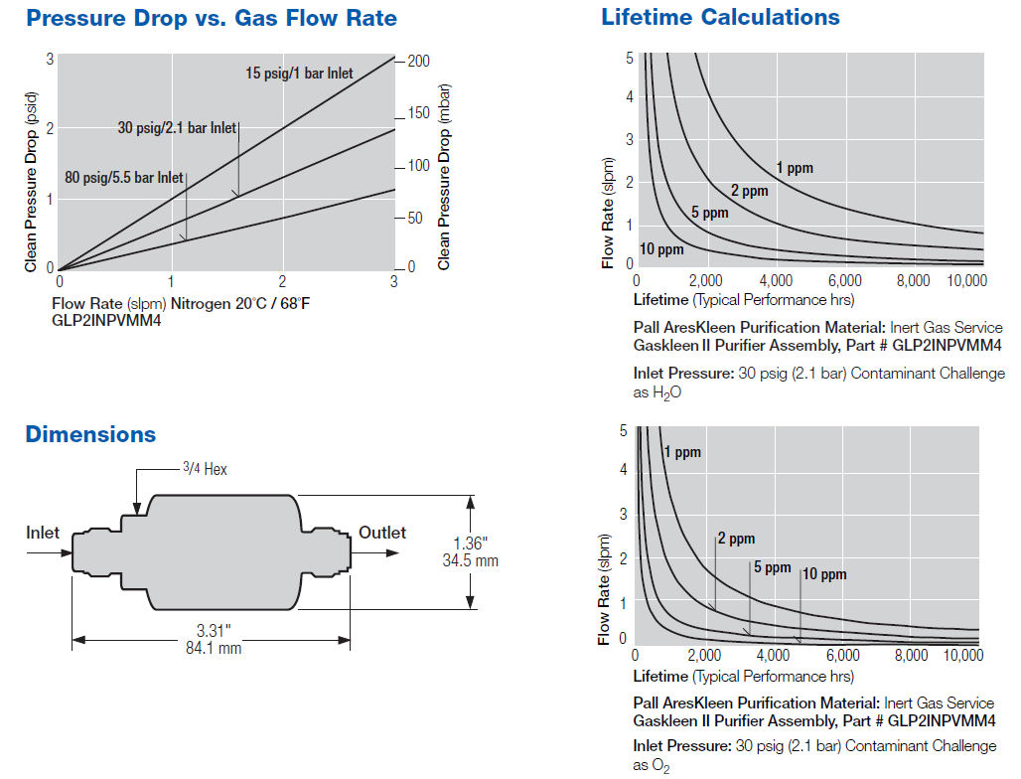

Filters
Option1: Matheson Tri-Gas Model 6164-T 316 Stainless Steel High Purity Depth Filter
- Microporous fiberglass used for filtering
- 100% filtration efficiency at 0.2 micron level
- Swagelok tube fittings (VCR, VCO fittings also available (6164-V)
- Various diameters available (1/8”, ¼”, 3/8”, ½”)
- Not sure if this will work at our pressures & pressure drop.
Option2: Matheson Tri-Gas Model 6190 0.01 Micron Membrane Gas Filter
- Teflon media used for filtering
- 100% efficiency at 0.01 micron
- Swagelok tube fittings (VCR MxM fitting also available)
- Not sue if this works at our pressures & pressure drop
Option3: See Purifier Option 4
Option 4: See Purifier Option 5
Mixing Baffle (a.k.a. Static Mixer)
Option1: KoFlo Stainless steel static mixer
- $1,071 for six-blade stainless steel mixer w/ 0.37” ID, 4” length
- …overkill
Option2: McMaster-Carr Inline Pipe Mixers
- Stainless steel
- Come with 6 or 12 blades in diameters from ½” to 2” diameters
- Cost: $240-580 for 6-blade, $350-880 for 12-blade
  - Price is pipe-diameter dependent
- More blades required for lower viscosity, but perhaps our fluid is too low of viscosity for this type of mixer to be effective
Vacuum Pumps
Option1: Edwards XDS10
- Does an excellent job thus far. I see no reason not to get another one, unless the cost ($6,257 on website) is prohibitively high
- Since shield gas (N₂) won’t be recirculated, perhaps a dry pump in unnecessary. Though I would recommend one so that there are not back-streaming concerns.
Molecular Sieve
- Option 1: Scientific Instrument Services Model & Price dependent on Pipe-diameter
  - MT-752K:
    - Traps hydrocarbons & H2O
      - NEED TO MAKE SURE CO2 is purified!
    - NW16-NW16 flange
    - 5cfm maximum flow
    - $295 for the trap + $30 for replacement zeolite charge
    - Bakeable
Cold Trap
- Option 1: Scientific Instrument Services LN2 Cold Trap
  - NW25 flanges
  - NEED TO MAKE SURE CO2 is trapped….though it should be at this temperature
  - 4” diameter, 11.5” height
  - $530. We need two: $1060
Differential Pressure Transducers
- Option 1: MKS 226A Differential Capacitance Manometer
  - Available for several Full Scale Ranges: 0.2-1000 Torr
  - Resolution: 0.01% of Full Scale
  - Accuracy: 0.5% of Full –sacle
  - Maximum Overpressure: 120% of Full Scale
  - Maximum Line Pressure: 40psig
  - Fitting & Full-scale range depend on model #, prices vary between $605-688
  - I think we’d like the 20mbar version with bi-directional calibration
    - NW16-KF flange fitting
    - Terminal adaptor block electrical connection
    - $688 - Wee need two: $1376
Pressure Transducers
- Option 1: MKS Type 622B Baratron
  - More or less equivalent to the 622A we already have (622A no longer made)
  - Full Scale Ranges between 1 and 1000 Torr
    - Accuracy 0.25% of reading for 1-1000 Torr (Model: 622B13TDE)
    - 0.15% for 10-1000 Torr optional upon request
      - Seemingly unnecessary as our 622A does the job just fine
  - NW16KF flange
  - 622B13TDE price: $1104. Counting the ballast tank, we need 2: $2208 (though maybe we don’t need something so accurate for the ballast tank)
Automated Valves
- Option 1: Kurt J. Lesker Company Bellows Sealed Angle Valves
  - Stainless Steel
  - High Conductance
  - Good to 10⁻⁹ torr; Leak less than 2e-9 scc/sec
  - 24V DC
  - KF16 or KF25 size
  - Assuming KF25: $436, Part number SA0100EVQF
    - We need 4: $1744
- Option 2: McMaster-Carr Sure-Seal Stainless Steel Solenoid Valves
  - NOT SURE WHAT VACUUM THEY’RE GOOD TO
  - Used for inert gases
  - For “low flow”
  - Buna-N seal
  - Connection type: NPT female
  - Pipe Size: 1/8” or ¼”; 1-5/8” x 2-7/8”
  - 120V AC or 24V DC
  - Price: $82.36-90.27 depending on details
  - Max PSI: 10-450 depending on details
  - Assuming we’ll use ¼ 24VDC 10PSI max: Product # 4639K163: $84.05
    - We need 4: $336.20
- Option 3: Swagelok Pneumatic-Actuated Low-Pressure valve with VCR fitting (free-floating)
  - For normally open, add –O to product # or –C for normally closed
  - All options have ¼” fitting:
    - Female VCR: 6LVV-DPFR4-
    - Male VCR rotatable: 6LVV-DPMR4-
    - Male VCR integral: 6LVV-DPVR4-
- Option 4: Swagelok IGC-II surface mount Pneumatic-actuated low-pressure valve
  - For normally open, add –O to product # or –C for normally closed
  - 1/8”-27 NPT inlet
  - 2-port normally opened: 6LVV-MSM-DP-2-P-O
  - 3-port normally opened: 6LVV-MSM-DP-3-P-O
  - ADD Indicator Switch:
    - 24” wire with in-line clip
    - Add M to product # for normally open, M-2 for normally closed
Manual Valves
- Option 1: Kurt J. Lesker Company Bellows Sealed Angle Valve
  - Stainless steel
  - High conductance
  - Good to 10e-9 torr; Leak less than 2e-9scc/sec
  - KF10 up to KF50 size
  - Assuming KF25: $280, Part number SA0100MVQF: We need 13: $3640
- Option 2: Swagelok IGC-II surface-mount toggle-actuated low-pressure valve
  - 2-port: 6LVV-MSM-DPT-2-P
  - 3-port: 6LVV-MSM-DPT-3-P
Regulators
- Option 1: McMaster-Carr Gas Pressure Control Regulator CGA 580:0-100 & CGA320:0-125
  - 580: 0-100: Product Number 7897A16
    - “Standard Duty”: steel & brass w/ two 2” diameter gauges & neoprene diaphragm
    - Two-Stage: Ensures a constant, steady delivery pressure, despite inlet fluctuation (One-stage is a little more than half the price)
    - 5/8”-18 right hand female
    - For Argon, Helium, Nitrogen
    - $265.16 each. We need two --$530.30
  - 320: 0-125: Product Number 7897A17
    - Same as above, but for Carbon Dioxide
    - $265.16 each. We need two $530.30
  - For all 4 required: $1060.60 ….5th required for storage tank?: $1325.80
Storage Tank
- Option 1: McMaster-Carr High Pressure Inert Service HP80 (Product No. 7822A14)
  - 2,265 liter capacity (at stp)
  - Used for Argon, Argon/CO2 blends, nitrogen, and helium
  - DOT 3AA-2015 standards: Max pressure 2,015PSI
  - $303.63
Heat Exchanger
- Option 1: Xchanger Model LC-12-1, ref data sheet #107241
  - 22”x25”x27”; 200lbs
  - …gave us quote assuming 300l/min flow instead of 5 as requested!!!!
  - Cost: $4,470
- Option 2: Exergy Sanitary 17 Series Shell & Tube
  - 0.12psi (6 torr) pressure drop
  - Cost: $1,800
- Option 3: Couldn’t we just get away with running the gas through a helical tube?
Gas Analyzer
- Option 1: Extrel MAX300 LG Gas Analyzer
  - Mass Range: 2-250amu
  - 165lbs (75kg); 60cm x 49cm x 68cm
  - NW 100CF (6 inch) flange!!!!!
  - Dual Faraday/Electron Multiplier detector
    - Upper Detection Limit: 100%
    - Lower detection limit: 10ppm Faraday, 10ppb Electro Multiplier
  - Communication via RS232
  - Software 1 (Merlin): Run in scan mode or single-ion monitoring mode
    - 80 microseconds per sample in scan mode
      - “Up to 72 ions with 20 scan segments”
    - 5ms per ion in single-ion mode
  - Software 2 (Questor 5): Analysis Rate: 400ms per component
  - Precision: ±0.0025 absolute; 30 Day Stability: ±0.005 absolute
  - Calibrated at factory with SF6 & again on-site with gases of our choosing
  - $66 minimum (see full quote)
  - Requires “very little gas”
- Option 2: MKS Cirrus 2 continuous gas analyzer
  - Continuous analysis
  - <100ppb detection of contaminants
  - 250 data points per second
  - 64.5 cm x 41 cm x 35cm; 34.5kg
  - 0.2sccm gas-consumption
  - $44,000
    - Includes travel, installation, + 1 day of training
- Option 3: SRI Instruments Multiple Gas Analyzer Gas Chromatograph
  - <100ppb detection for most contaminants
  - (Would need to be calibrated b/c a gas chromatograph)
  - $16,275
Ballast Tank
- Option 1: McMaster-Carr ASME-Code Horizontal Pressure Tank 9426K14
  - Need 340 liters worth of storage
    - P₁V₁=P₂V₂, P₁=550torr V₁=500liter, P₂=800torr V₂=340liter
  - ..so we go for tank with 120gallons internal volume: 454liters
  - Choose epoxy-lined steel: Model 9426K14
  - 24”x67”x31”
  - 7 openings, NPT Female type
  - Good for down to 270torr
  - Cost: $1128.45

