Quantifying Substances
in a Mixture
This laboratory will focus on the quantification of chemicals in a complex mixture. In a previous lab experiment, you observed how complex mixtures of stubstances could be separated and identified by gas chromatography through retention times. Now you will study a mixture containing unknown quantities of ethyl acetate and butyl acetate. You will use a sequential addition calibration curve to calculate the concentrations of the two esters in the mixture.
Standard addition calibration curves are used in instrumental analysis to determine the concentrations of analytes present in a mixture. Many times researchers will use a calibration curve, which looks at the peak area of a pure sample at known concentrations to determine the concentration in an unknown. However, this approach does not account for the matrix effect problem, which occurs when interactions between the analyte and impurities in a complex mixture alter the signal or change the peak area that is observed.
One way to solve the matrix effect is to perform a standard addition calibration curve. This is done by starting with a known quantity of complex mixture and sequentially adding known quantities of the substances of interest. You will not know how much was in the solution initially but you will know how much standard solution was added, and how the readings changed after adding the standard solution. Thus, you can use this information to determine the concentrations present initially in the unknown solution, as shown in the diagram below.
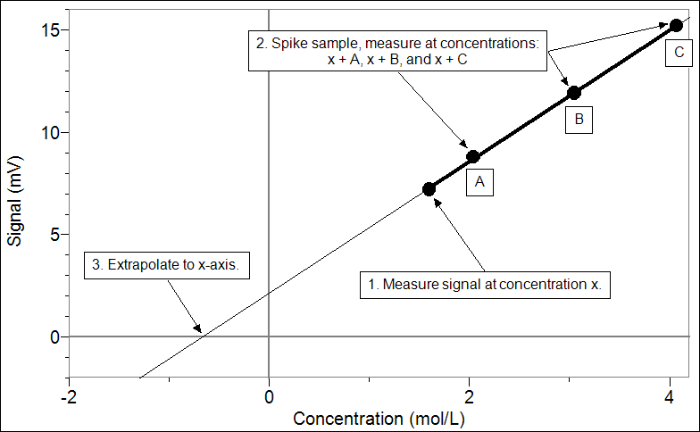
Figure 1: Analysis of a mixture
In this experiment you will determine the concentrations of the two esters in the mixture. You will use a Vernier Mini GC to measure the retention times of a series of mixtures, using the unknown, that have been spiked with a specific amount of each compound. By examining the retention graphs and calculating the peak areas, you will determine the concentrations of the unknown mixture of the esters.
OBJECTIVES
In this experiment, you will
- Prepare a set of standard mixtures of two esters, ethyl acetate and butyl acetate, starting with a mixture whose composition of the esters is unknown.
- Measure and analyze the GC retentions time of the standard mixtures.
- Analyze the data to determine the concentrations of ethyl acetate and butyl acetate in the original unknown mixture.

MATERIALS
Vernier Mini GC | ethyl acetate (EtOAc)
computer or LabQuest | butyl acetate (BuOAc)
Logger Pro 3 or LabQuest App | acetone
1 μL glass syringe  5 vials with caps | unknown mixture of EtOAc, BuOAC, and acetone
Kimwipes® or paper towels | small beaker to collect waste liquid
 | three 1 mL transfer pipets and pipet pump

PROCEDURE
1. Obtain and wear goggles.
2. Obtain a glass syringe and five vials for your standard solutions. Obtain small volumes of the pure reagents (acetone, ethyl acetate, and butyl acetate) and the unknown mixture.
Important: The glass syringe is fragile and can be easily damaged. Be careful not to bend the needle or bend the plunger. If the plunger is accidentally pulled out of the glass barrel, reinserting it is extremely difficult, sometimes impossible.
3. Prepare 5 standard solutions as described in the mixing chart below. Use pipettes to mix these quantities. Seal the vials with a cap or a square of Parafilm.
Vial | Unknown mixture of EtOAc, BuOAc, and acetone  (mL) | Ethyl acetate  (mL) | Butyl acetate  (mL)
1 | 0.60 | 0.40 | –
2 | 0.60 | 0.30 | 0.10
3 | 0.60 | 0.20 | 0.20
4 | 0.60 | 0.10 | 0.30
5 | 0.60 | – | 0.40

4. Prepare the Vernier Mini GC for data collection.
- Turn on the Mini GC.
- Connect the USB cable of the Mini GC to the USB port on your computer or LabQuest.
- Start the data-collection program, and then choose New from the File menu.
- Click Collect in Logger Pro, or tap ► in LabQuest, to bring up the Temperature-Pressure profile.
- Set the Temperature-Pressure values to:

Start temperature | 35°C
Hold time | 2 min
Ramp rate | 5°C/min
Final temperature | 55°C
Hold time | 9 min
Total length | 15.0 min
Pressure | 5.0 kPa

- Select Done to initiate the Mini GC warm up. Note: A new message will appear, “Do not inject until GC is ready,” and the LED on the Mini GC is red. The Mini GC will take a few minutes to warm up and stabilize. When the Mini GC is ready for injection in Step 7, the message will read, “Inject and select Collect simultaneously,” and the LED will turn to green. Continue with Step 4 during warm up.

4. Follow the steps below to clean and flush the syringe with acetone. Important: The glass syringe is fragile. Be careful not to bend the needle or bend the plunger. Never pull the plunger back more than 50% of its total volume. Be careful not to bend the plunger as you press it down.
- Depress the plunger fully.
- Submerge the tip of the syringe needle into the vial of acetone.
- Pull back the plunger to fill the barrel about 1/3 full of acetone. Examine the barrel of the syringe and estimate the amount of acetone in the barrel.
- Expel the liquid onto a Kimwipe or a paper towel.
- Repeat Steps a–d at least two more times, until you are comfortable pulling up a liquid into the syringe and measuring the volume in the syringe barrel. Use a Kimwipe or a paper towel to carefully pat around the tip of the syringe needle.

5. Clean and flush the syringe with the mixture in Vial 1, the first sample to be injected in the
Mini GC.
6. Collect a volume of the mixture in Vial 1 for injection.
- Submerge the needle into Vial 1.
- Draw up 0.3 μL of liquid. Make this measurement as accurately as possible; it will make your analysis much easier if the injection volumes are the same for each sample.
- After collecting your sample, use a Kimwipe to gently wipe the needle from barrel to tip.

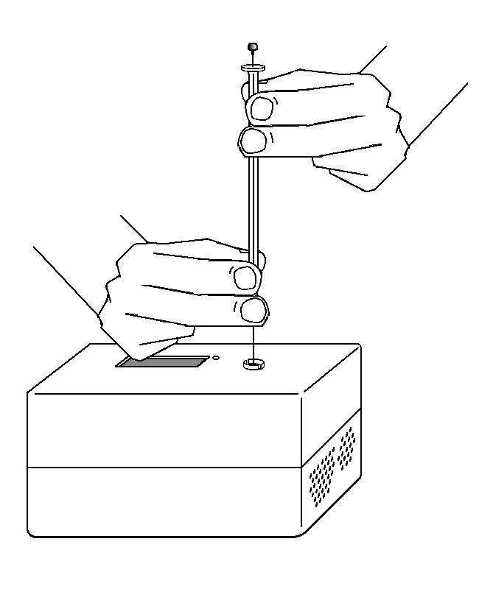7. Prepare for injection and the start of data collection. It is important for you and your lab partner to divide the tasks in this step. One person will operate the syringe and the other person will operate the computer controls.
Figure 2
- When the Mini GC has reached the correct start temperature and pressure, the message reads, “Do not inject until GC is ready” and the LED on the Mini GC is green.
- To insert the needle of the syringe into the injection port of the Mini GC, hold the syringe with one hand and steady the needle with your other hand. Insert the needle into the injection port until the needle stop is fully seated, as shown in Figure 2. If the needle sticks, rotate it slightly while inserting. Do not move the plunger yet.
- Simultaneously, depress the syringe plunger and select Collect to begin data collection. Pull the needle out of the injection port immediately.

8. While the data collection proceeds, repeat Step 4 to thoroughly clean the syringe and needle. It may take more than three flushes to feel the syringe plunger move smoothly again, which is your indicator that the syringe and needle are both suitably clean.
9. Data collection will end after 15 minutes. Observe the graphed data that describe the chromatogram for this mixture. Note the three peaks on the graph. At this point in your experiment, the identity of each peak may not be evident, but it can be helpful to speculate about the order in which the compounds elute through the Mini GC.
10. To store the data, choose Store Latest Run from the Experiment menu in Logger Pro or tap the File Cabinet icon in LabQuest.
11. Prepare to conduct a new data collection run.
- Click Collect in Logger Pro, or tap ► in LabQuest, to bring up the Temperature-Pressure profile. This profile will be the same as for your previous run. If you are satisfied with these values, click OK to initiate the Mini GC profile.
- While the Mini GC adjusts to its Temperature-Pressure profile, repeat Steps 5 and 6 with the sample in Vial 2.
- After the Mini GC is ready, repeat Steps 7–10 using your Vial 2 sample.

12. Repeat Steps 5–10 for the mixtures in Vials 3-5. After you have conducted 2 or 3 runs, the order in which the compounds are eluting the Mini GC may reveal itself.
13. After you have injected the sample from Vial 5, clean the syringe with acetone (Step 4) as part of cleaning your lab area at the conclusion of the experiment. Turn of the Mini GC.
DATA TABLE
Median Peak Area of Acetone

Vial | Peaks | Calculated Peak Area | Scaled Peak Area
1
 | Acetone |  | (not needed)
 | EtOAc
 | BuOAc
2
 | Acetone |  | (not needed)
 | EtOAc
 | BuOAc
3
 | Acetone |  | (not needed)
 | EtOAc
 | BuOAc
4
 | Acetone |  | (not needed)
 | EtOAc
 | BuOAc
5
 | Acetone |  | (not needed)
 | EtOAc
 | BuOAc

DATA ANALYSIS
1. Determine the identity of the three peaks in the chromatograms.
Peak | Compound
One
Two
Three

2. You will use the chromatograms to calculate the ratios of butyl acetate and ethyl acetate present in your unknown mixture. The acetone in the mixture is used as an internal standard. The peak area of acetone should stay the same for each solution because you did not change its concentration from one solution to the next. If the peak area of acetone differs, that is most likely due to inconsistencies in the injection volume. Follow the steps below to analyze each chromatogram.
- Plot Run 1 on your graph. This is the GC run for Vial 1.
- Choose Peak Integration from the Analyze menu.
- Select and integrate the left-most peak. To do this, drag from a little before the peak to a point far enough to the right that includes all of the peak. Then choose Add.
- Record the peak area in the third column of your data table (Calculated Peak Area).
- Enter the name of the compound, if known.
- To analyze another peak on the same graph, repeat Steps c and d.
- When you are finished with all of the peaks, select OK.

3. Repeat Step 2 for Runs 2-5.
4. The peak area of acetone is considered standard. To determine this peak area, examine the peak areas for acetone in column three and identify the median value. Record this quantity in box above your data table.
5. To calculate the scaled peak area for each ester, divide the calculated peak area by the median peak area of acetone. The scaled peak areas will help you account for slight differences in the injection volumes of each run.
6. Create a graph which plots scaled peak areas (y-axis) vs. molar concentration of ethyl acetate added (x-axis). Draw a best-fit line that intersects the x-axis. The absolute value of the
x-intercept will equal the concentration of ethyl acetate originally present in the mix. Refer to Figure 1, in the introductory remarks, to help you analyze your new graph.
7. Repeat Step 6 to create a second graph for butyl acetate and find the x-intercept to determine the molar concentration of butyl acetate.

