<<Name of Tour>> Tour of FRIB
<<Day of Week, Day Month Year>>
<<Start Time>>
<<End Time>>
<<Name Primary Tour Guide>>, Primary Tour Guide

Summary:
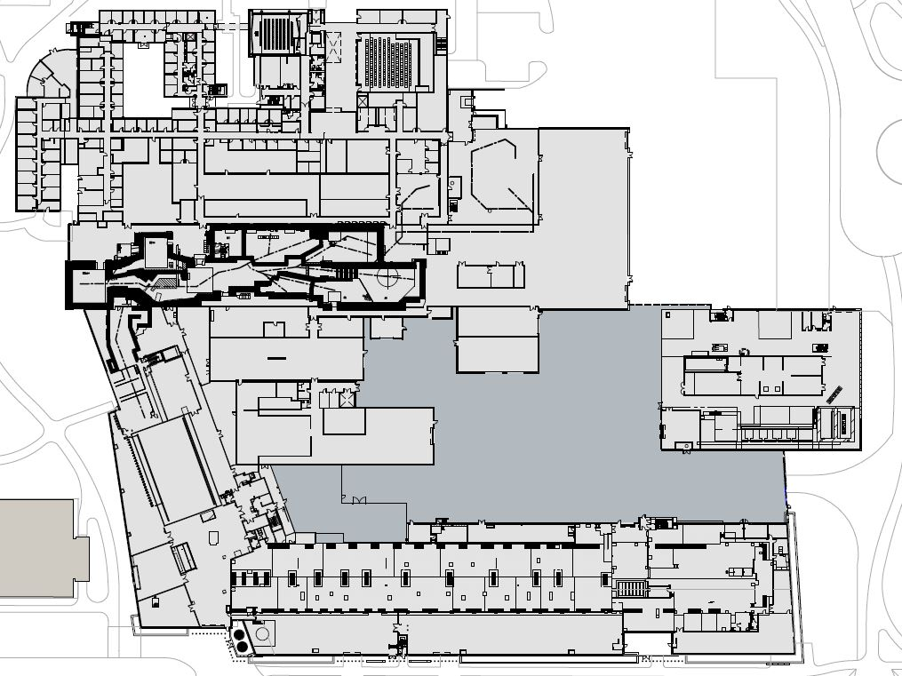
The <<Name of Tour>> tour attendees will gather in the <<room location>> for an orientation and tour overview delivered by <<Name of Primary Tour Guide>>. The attendees will break into groups consisting of no more than 15 attendees. Each tour group will have an assigned escort. Escorts will accompany each tour group to the tour stops indicated on the tour map below. Escorts will make sure the group stays together and tour attendees do not touch anything and do not take photographs. Escorts will also provide instructions in the unlikely event of an emergency. <<Start Optional text>>Information at tour stops will be presented by subject matter experts. Time for all stops will be uniform. As there are more stops than groups, the presenters will have some unoccupied time intervals in between groups <<Stop Optional Text>>.
Tour stop indicator
1
Figure 1: Tour Map should indicate tour route and optional tour stop locations.

Primary Tour Guide:
The Primary Tour Guide, <<Name of Primary Tour Guide>>, will complete a Work Control Plan Assessment form and attach these Tour Instructions at least one week in advance of the start of the tour. The Primary Tour Guide will complete the FRIB Tour Safety Checklist (Outreach Wiki) and, if the tour will include the FRIB Tunnel (SB608), the FRIB Tunnel Tour Checklist (T30102-FM-000231), within 24 hours of the start of the tour. The Primary Tour Guide will attend the 8:30 am Accelerator Systems Division Work Control Plan Meeting when requested. The Primary Tour Guide will also attend the 8:00 am NSCL Coordination Meeting and the 8:10 am Accelerator Systems Division Commissioning Meeting that fall closest to the start of the tour.

Escorts for tour groups:
The individuals listed below will serve as escorts for the <<Name of Tour>> tour of FRIB. Escorts must have the appropriate training and the necessary access to complete the tour route indicated in the above tour map. Escorts will wear the appropriate personal protective equipment and their radiation film badges during the tour. Escorts will be responsible for making sure that tour participants stay with their assigned tour group, do not touch any equipment, do not take any photographs and do not go beyond posted barriers. Escorts will attend the 8:00 am NSCL Coordination Meeting and the 8:10 am Accelerator Systems Division Commissioning Meeting that fall closest to the start of the tour.
- <<Escort Name>>  - <<Escort Name>>  - <<Escort Name>>  - <<Escort Name>> | - <<Escort Name>>  - <<Escort Name>>  - <<Escort Name>>  - <<Escort Name>>

<<Start Optional Section>>

Tour Stops and Subject Matter Experts:
Information at tour stops will be presented by subject matter experts. If an emergency occurs, the subject matter experts will assist escorts in leading tour participants to safety. Subject matter experts will also assist in confirming that no tour participants remain in their area when the tour group moves to the next tour stop.
<<Name of Tour>> Tour Stops
Start | Duration | Stop # | Agenda Item | Room # | Subject Matter Experts | Area Managers
#:## #M | #:## | # | <<Tour Stop Location>> | #### | <<SME Name>> | <<Area Manager Name>>
#:## #M | #:## | # | <<Tour Stop Location>> | #### | <<SME Name>> | <<Area Manager Name>>
#:## #M | #:## | # | <<Tour Stop Location>> | #### | <<SME Name>> | <<Area Manager Name>>
#:## #M | #:## | # | <<Tour Stop Location>> | #### | <<SME Name>> | <<Area Manager Name>>
<<End Optional Section>>
Signatures (required for tours with tour stops) or Notifications listing:
Prepared by: <<Primary Tour Guide>>
Reviewed by: <<Deputy Laboratory Director>>
Approved by: <<Laboratory Director>>
Concurrence by: Area Managers for Areas along tour route
Concurrence by: FRIB Cryogenic Department Manager and FRIB Tunnel Area Coordinator (SB608), if FRIB Tunnel is included in tour route

