An FRIB non-public tour has the following attributes
- Not openly communicated and offered to the general public
- Serves the educational and/or business needs of the laboratory
- Route includes areas where the participants (including escorts) do not regularly execute or oversee work
FRIB non-public tour general guidelines
- Limit of 15 participants per tour escort
- Scheduled during business hours (M-F; 8 am – 4 pm)
  - Exception for VIPs, Science Conferences, and Technical Meetings
- Participants must wear PPE (vest, safety glasses, hard hard)
- Participants must be briefed on compliance to safety, egress, and video/photo postings
- Participants must remain in sight of tour guide
- All participates over 16 years of age
- Tour time is typically around 60 minutes
FRIB non-public tours are arranged through Outreach Coordinator
- Schedules date and time
- Collects information on attendees for non-public tour
- Provides advanced material on location and arrival logistics
- Maintains record of tour groups
- Completes Tour Checklist for areas associated with NSCL Operations
- Schedules presentation room and arranges for PPE from CFID
FRIB non-public tours are organized by Deputy Laboratory Director
- Reviews planned activities with FRIB Commissioning, Operations and Area Managers
- Makes Tunnel/Non tunnel decision
- Coordinates execution of tour with Primary Tour Guide
- Ensures that Primary Tour Guide submits Work Control Plan
FRIB non-public tours are led by Primary Tour Guide
- Prepares the Tour Instructions from the available template
- Submits the Work Control Plan, that includes the Tour Instructions
- Completes the FRIB Tour Safety Checklist for areas associated with FRIB
- Completes the FRIB Tunnel Tour Checklist for tours that include the FRIB Tunnel (SB608)
- Attends the 8:30 am ASD Work Control Plan Meeting when requested
- Attends the 8:00 am (NSCL) and 8:10 am (FRIB) planning meetings the day of the tour
- Responsible for ensuring that all tour participants exit the FRIB building at the end of the tour
FRIB non-public tours are conducted by Tour Escorts
- Have appropriate training
- Wear PPE, Dosimeter
- Attend 8:00 am (NSCL) and 8:10 am (FRIB) planning meetings the day of the tour
- Keep participants in sight for duration of tour
- Enforce safety, egress, and video/photo postings

FRIB Tour Decision Tree

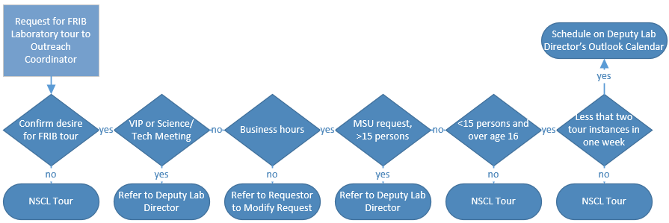
Non-public, non-conference generic Tour Routes
- FRIB Service Building with Tunnel
- Enter northeast door by new CAB construction in 1631
- Stops
  - Front end (1633)
  - Stairwell (SW15) 1 to SB
  - Tunnel (SB608)
  - Elevator (near SW13) from SB to B
  - Target Facility (B605)
  - Elevator (near SW13) from B to 1
  - Exit door along 1HW16by Commissioning Control Room
  - Commissioning Control Room (Trailer #9)
  - Enter door along 1HW16 by Commissioning Control Room
  - Rack Room (1624)
  - Exit 1631 via northeast door by new CAB construction
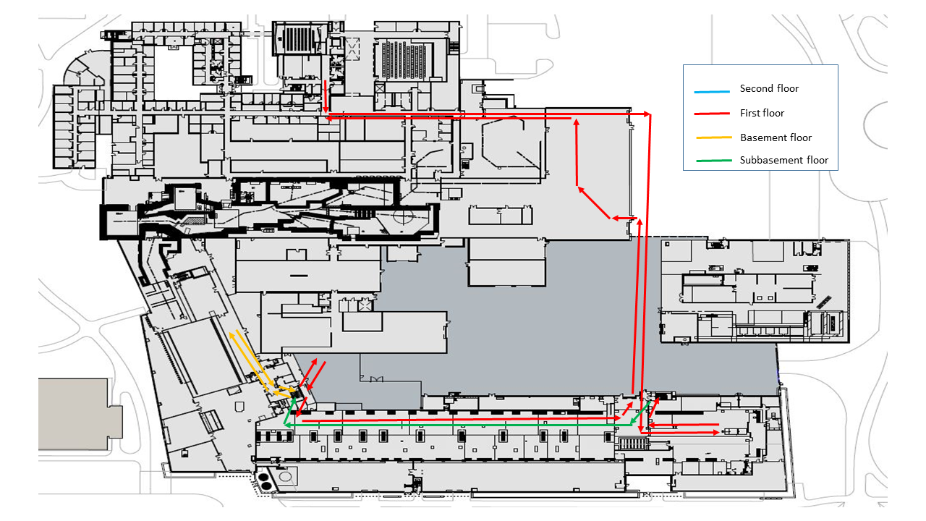
  - FRIB Service Building with No Tunnel
- Enter northeast door by new CAB construction
- Stops
  - Front end (1633)
  - Rack room (1624)
  - Elevator (near SW13) from 1 to B
  - Target Facility (B605)
  - Elevator (near SW13) from B to 1
  - Exit door along 1HW16 by Commissioning Control Room
  - Commissioning Control Room (Trailer #9)
  - Enter door along 1HW16 by Commissioning Control Room
  - Elevator (near SW13) from 1 to 2
  - Cryogenic Control Room (2616)
  - Stairwell (SW15) from 2 to 1
  - Exit 1631 via northeast door by new CAB construction
