Location: General interest – point these out when you see a good example or need to fill time  A detector for measuring nuclei exiting the ReA6 reaccelerator |  | Approval:
Safety/Notes: Watch for crane operation! Gates require card activation, which requires ReA6 access training. Flashing yellow light next to the cylindrical magnet indicates magnetic field on - keep visitors behind the blue/white stripe on the floor.
For all audiences | For all audiences | For all audiences
- In nuclear science, we build large machines to study tiny particles to understand giant stars.  - Note changes in floor and wall colors, indicating that we’ve added on to the building. The original building was occupied in 1964, we’ve added on 15 times!  - The electronics: most built right here at FRIB designed to do high-speed, high-volume data acquisition.  - Pipes around the building carry cooling water (Low-Conductivity Water, or LCW, reduces corrosion in copper equipment) and liquid nitrogen (LN). We consume 3000 gallons (12000 liters) of liquid nitrogen every week, costing only 26 cents per gallon (7 cents/liter). We make liquid helium on-site in the nation’s largest LHe cryoplant, delivered @ 4.5 or 2K.  - Power supplies and power cables: FRIB will be powered by MSU power plant, Consumers Energy in East Lansing, and Lansing’s Board of Water and Light. While running, FRIB will consume ~14 MW, or the equivalent of more than 30,000 houses. We have our own substation! If power fails, we have on-site generators to keep the pumps running. MSU power plant gives us priority when power returns. (from Andreas)  - Ethernet cables: carry commands/feedback to/from the control room and experimental data to Data-U.  - Walls: The concrete blocks are stacked around equipment to prevent radiation from escaping. All are at least 6 feet thick, based on calculations that show 200 MeV neutrons produced would still result in less than 10 mRem exposure per year even if we ran experiments 24/7. The wall blocks are not mortared together so they can be easily removed and re-stacked (like big LEGOs), completely changing the layout of the laboratory as needed! Science and technology change quickly, so the laboratory can change to accommodate new technology or techniques. | - The vault-seal alarm: in order to run beam in a vault, hit the red button that informs everyone to GET OUT with lights and sound (music from Close Encounters of the Third Kind), then you seal the door. Unsealing the door automatically cuts off the beam to that vault.  - Vault doors: when we’re ready to seal a vault to run beam through it, you must hold the button to close (safety feature!). The doors are solid concrete, 10-15 tons, about as thick as the walls to contain the radiation. When they close fully, switches at the top are tripped to inform the operators in the control room that the vault is sealed.  - The 40-ton crane (yellow bridge) that can travel the length of the room. The crane could lift one Apatosaurus (Brontosaurus) plus 2 Tyrannosaurs. The vaults are built of concrete blocks with concrete beams (10+ tons) for roofs.  - As tall as the research space is, it goes as deep under your feet (at ground level) as well.  - Noise in the vaults is usually vacuum pumps like the “roughing pumps” found on the floors next to beamlines. We also have diffusion pumps (compresses the air with an oil cascade before pumping out) and cryopumps (literally freeze the air out of the pipe). We need to remove the atmosphere from the beam line so the air molecules don’t interfere with the motion of the beam nuclei. Pressures are commonly one-billionth of an atmosphere (10⁻⁶ Torr) or lower.  - Even when running, the radiation levels are small. You are far more likely to be hurt in a car accident that by radiation in our lab. FRIB does not exceed regulatory radiation exposure limits (from Andreas). Industrial hazards (falling, tripping, etc.) are more common. | - Magnet quenching: there are failsafes/pressure release valves to protect superconductors from an uncontrolled switch to normal conduction. In the event of a large release of boiled-off LN, the Oxygen Deficiency alarms in each vault will alert staff if percentage goes below 19.5%.  - The black disks (occasionally covered by red caps) on the walls in the research area serve as known points in space, and are used with a laser surveyor to position equipment. They serve as the lab’s “GPS”.  - Annual FRIB operating budget will be about $100 million from the US DOE Office of Science  - NSCL discovered 77 isotopes in three decades. FRIB is expected to discover at least 1000 new isotopes  - FRIB will have ~800x the beam intensity of NSCL’s Coupled Cyclotron facility (400 kW vs 0.5 kW)  - 500 m long linear accelerator, 10 m underground  - Largest liquid helium plant in the U.S., recovering 100% of the gas for reliquifying  - 300 kW of beam will be unreacted, so it can go to the isotope harvesting station to make medical isotopes.  - FRIB will access about 5000 different isotopes.  - 450-meter-long accelerator folded to fit in the 150-meter-long tunnel  - FRIB will be able to slam 50 trillion uranium ions per second into its target.  - We know the neutron dripline up to element 10, neon. FRIB is expected to determine the neutron drip line up to the 30th element, zinc, maybe even farther!  - FRIB may identify 80 percent of possible isotopes for all elements up through uranium

Location: Data-U (#1 on the tour locations map)  The area where users (researchers) monitor data from their experiments |  | Approval: Daniel Bazin (1/9/17)
Safety/Notes: If there are users in the Data-U, avoid disturbing them and give your speech in a different section.

General audiences | Young students (revised language) | HS/College science students (extra info)
- Researchers (users) are in here 24 hours a day during their experiment, observing data coming to one of the computer banks from whichever detector they’re using. There is one Data-U matched to each vault.  - FRIB serves over 1500 users from over 50 countries.  - The cost to research time at NSCL is effectively $5000/hr, which is not required of the user but comes from the U.S. Department of Energy Office of Science.  - Beam time is free to the user, but they must “pay back” by publishing their results, adding to human knowledge.  - The average experiment runs for about one week, twenty-four hours per day. Researchers must staff three shifts of 8 hours in this space (like a factory), including a midnight shift.  - The average experiment produces about 100 terabytes of information. Researchers will take that data home for analysis, filtering out “background noise” and comparing detected signals with model predictions, and eventually publishing their results in a publically-available journal. FRIB is a factory that produces new knowledge for humanity.  - The first call for experiment proposals was due in February 2021, review was completed in August 2021. 30% of requested time was approved. The 401 researchers on the first round of proposals represented 25 countries, 24 states, and 88 institutions.  - The next call for proposals is in summer 2022, with review in March 2023. | - Researchers (users) are in here 24 hours a day during their experiment, observing data coming to one of the computer banks from whichever detector they’re using. There is one Data-U matched to each vault.  - FRIB serves over 1500 users from over 50 countries.  - Any of those scientists worldwide can ask for research time here. The best ideas are chosen to do experiments that last about a week on average.  - We don’t charge them to do an experiment because it would cost $5000/hr, which they probably could not afford! The U.S. Department of Energy Office of Science pays for research to happen here.  - The average experiment runs for about one week, twenty-four hours per day. Researchers must staff three shifts of 8 hours in this space (like a factory), including a midnight shift. | - The racks of electronics are connected to the vaults with many cables so experimenters can make changes without having to stop the beam and open the vault door.  - Data-U sometimes contains the complex electronics required to rapidly collect, process and store data, but most equipment is located remotely and computer-controlled.  - Running an experiment requires that you apply for beamtime, set up about one month in advance, have group monitoring in Data-U for length of experiment (average 120 hours, about one week), then spend months analyzing the data with the goal of publishing, and writing Ph.D. dissertations.  - Anyone in the user community can propose an experiment, and those proposals are reviewed by a committee (PAC) featuring some of the nation’s top nuclear scientists. (Note: NSCL representatives on that committee are non-voting) The PAC selects the most critical and achievable research and approves beam time. They can only accept about 1/3 of the proposals (~40 experiments/year)!

Location: Control Room (#2 on the tour locations map)  Where on-shift operators manage the accelerator and deliver beam to the experiment. |  | Approval: Andreas Stolz
Safety/Notes: No safety issues. This is a good location to visit when many vaults are closed, or you’re waiting for another group to move on
General audiences | Young students (revised language) | HS/College science students (extra info)
- While the NSCL is running an experimental program, operators are here 24 hours a day monitoring systems and maintaining beam output. We generally have three shifts, like a “nucleus factory”! We run experiments ~4000 hours per year, with maintenance shutdowns and tests making up the remainder of the year.  - Operating the accelerator is done remotely from the control room. Operators maintain the beam by “tuning” devices to produce quality beams that satisfy the users’ needs.  - An example beam current (for O-16): 625 billion particles per second ~ 100 pnA ~ 0.2 kW.  - Some monitors show video feeds from points where operators can insert a fluorescent screen to “see” the beam (bright spot) in real time while adjusting its position, size, and shape. This works like old TV picture tubes.  - The majority of software used by our operators to control the facility is developed here at FRIB and runs on standard PCs running Windows. Operators can adjust settings and turn devices on and off in software (clicking a button or typing a new value) or by adjusting hardware knobs. These computers connect to thousands of sensors for diagnostics.  - Hallway displays detail the current experiment, accelerated isotope, selected isotope, availability (reliability), vaults security status, etc. Our lab’s availability is generally > 90%, which is great for a lab our size.  - Operators typically have a bachelor’s or master’s degree in physics or engineering, and also possess skills in fields such as programming, maintenance, fabrication and electronics.  - When FRIB is not running experiments, we are performing maintenance and upgrades, where the additional skills of the operators are put to use.  - Operators are highly-skilled and trained. In many cases they are the only people with working knowledge of how to control and repair a particular piece of equipment. It takes ~9 months to qualify as an operator-in-charge.  - Operating the cyclotron controls is similar to a pilot flying (operating) a 747. Just as a pilot is not an expert in aeronautics, operators are not experts in particle physics. Both need a deep understanding of all the systems at their disposal and confidence to operate them successfully.  - Over 30,000 settings and readings of equipment are recorded constantly throughout the day by the NSCL’s control system. | - While the NSCL is running an experimental program, operators are here 24 hours a day monitoring systems and maintaining beam output. We generally have three shifts, like a “nucleus factory”! We run experiments ~4000 hours per year, with maintenance shutdowns and tests making up the remainder of the year.  - Operating the accelerator is done remotely from the control room. Operators maintain the beam by “tuning” devices to produce quality beams that satisfy the users’ needs.  - An example beam current (for O-16): 625 billion particles per second ~ 100 pnA ~ 0.2 kW.  - Some monitors show video feeds from points where operators can insert a fluorescent screen to “see” the beam (bright spot) in real time while adjusting its position, size, and shape. This works like old TV picture tubes.  - The majority of software used by our operators to control the facility is developed here at FRIB and runs on standard PCs running Windows. Operators can adjust settings and turn devices on and off in software (clicking a button or typing a new value) or by adjusting hardware knobs. These computers connect to thousands of sensors for diagnostics.  - Hallway displays detail the current experiment, accelerated isotope, selected isotope, availability (reliability), vaults security status, etc. Our lab’s availability is generally > 90%, which is great for a lab our size.  - Operators typically have a bachelor’s or master’s degree in physics or engineering, and also possess skills in fields such as programming, maintenance, fabrication and electronics.  - When FRIB is not running experiments, we are performing maintenance and upgrades, where the additional skills of the operators are put to use.  - Operators are highly-skilled and trained. In many cases they are the only people with working knowledge of how to control and repair a particular piece of equipment. It takes ~9 months to qualify as an operator-in-charge.  - Operating the cyclotron controls is similar to a pilot flying (operating) a 747. Just as a pilot is not an expert in aeronautics, operators are not experts in particle physics. Both need a deep understanding of all the systems at their disposal and confidence to operate them successfully.  - Over 30,000 settings and readings of equipment are recorded constantly throughout the day by the NSCL’s control system. | - While the NSCL is running an experimental program, operators are here 24 hours a day monitoring systems and maintaining beam output. We generally have three shifts, like a “nucleus factory”! We run experiments ~4000 hours per year, with maintenance shutdowns and tests making up the remainder of the year.  - Operating the accelerator is done remotely from the control room. Operators maintain the beam by “tuning” devices to produce quality beams that satisfy the users’ needs.  - An example beam current (for O-16): 625 billion particles per second ~ 100 pnA ~ 0.2 kW.  - Some monitors show video feeds from points where operators can insert a fluorescent screen to “see” the beam (bright spot) in real time while adjusting its position, size, and shape. This works like old TV picture tubes.  - The majority of software used by our operators to control the facility is developed here at FRIB and runs on standard PCs running Windows. Operators can adjust settings and turn devices on and off in software (clicking a button or typing a new value) or by adjusting hardware knobs. These computers connect to thousands of sensors for diagnostics.  - Hallway displays detail the current experiment, accelerated isotope, selected isotope, availability (reliability), vaults security status, etc. Our lab’s availability is generally > 90%, which is great for a lab our size.  - Operators typically have a bachelor’s or master’s degree in physics or engineering, and also possess skills in fields such as programming, maintenance, fabrication and electronics.  - When FRIB is not running experiments, we are performing maintenance and upgrades, where the additional skills of the operators are put to use.  - Operators are highly-skilled and trained. In many cases they are the only people with working knowledge of how to control and repair a particular piece of equipment. It takes ~9 months to qualify as an operator-in-charge.  - Operating the cyclotron controls is similar to a pilot flying (operating) a 747. Just as a pilot is not an expert in aeronautics, operators are not experts in particle physics. Both need a deep understanding of all the systems at their disposal and confidence to operate them successfully.  - Over 30,000 settings and readings of equipment are recorded constantly throughout the day by the NSCL’s control system.
Location: K500 Cyclotron (#3a on the tour locations map)  The primary accelerator for NSCL from 1982-2020 |  | Approval: Jon Bonofiglio (1/26/17)
Safety/Notes: Watch out for low ceilings and protruding objects. Assume objects on benches or yellow mat are radioactive, keep a distance away and never touch. When K500 magnet is on, do not approach door or walk down adjacent hallway! There is a yellow light by the door from the atrium and near the control room hallway. Do not pass the ion sources nor enter the K1200 with public tours, due to concerns about x-ray radiation.
General audiences | Young students (revised language) | HS/College science students (extra info)
- World’s first superconducting cyclotron  - 10 feet (over 3 meters) wide, 5 stories tall  - Dees/Pole tips (look like “fan blades”) at the center are electrical poles, which are charged and discharged millions of times per second up to 60-65 kV. The electric field produced is used to accelerate the ions through attraction/repulsion. The copper pillars above and below the cyclotron are what charge them.  - The nuclei inside orbit almost exactly 250 times before leaving at their maximum velocity (0.15 c, 30000 miles/ sec, 45 million m/s).  - A “helium can” contains 20 miles (32 km) of superconducting wire in coils bathed in liquid helium, like many of the magnets we use to steer the beam. The coil generates a strong enough magnetic field (3-5 Tesla) to keep fast-moving nuclei in a circular orbit.  - The cyclotrons (K500 & K1200) were shut down in November in 2020 so the fragment separator could be reconfigured to connect with the FRIB linac. They will be repurposed and reused in the future, but we don’t yet know how.  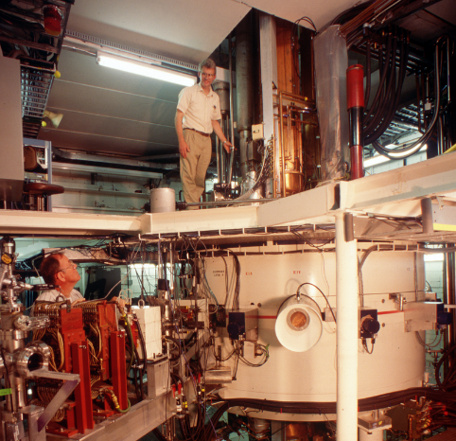  - Peter Miller standing on top of the K500 | - World’s first superconducting cyclotron  - 10 feet (over 3 meters) wide, 5 stories tall  - Dees/Pole tips (look like “fan blades”) at the center are electrical poles, which are charged and discharged millions of times per second up to 60-65 kV. The electric field produced is used to accelerate the ions through attraction/repulsion. The copper pillars above and below the cyclotron are what charge them.  - The nuclei inside orbit almost exactly 250 times before leaving at their maximum velocity (0.15 c, 30000 miles/ sec, 45 million m/s).  - A “helium can” contains 20 miles (32 km) of superconducting wire in coils bathed in liquid helium, like many of the magnets we use to steer the beam. The coil generates a strong enough magnetic field (3-5 Tesla) to keep fast-moving nuclei in a circular orbit.  - The cyclotrons (K500 & K1200) were shut down in November in 2020 so the fragment separator could be reconfigured to connect with the FRIB linac. They will be repurposed and reused in the future, but we don’t yet know how.  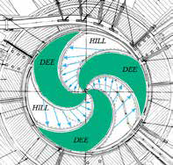  Top-down blueprint of cyclotron interior | - World’s first superconducting cyclotron  - 10 feet (over 3 meters) wide, 5 stories tall  - Dees/Pole tips (look like “fan blades”) at the center are electrical poles, which are charged and discharged millions of times per second up to 60-65 kV. The electric field produced is used to accelerate the ions through attraction/repulsion. The frequency can be adjusted to suit the beam by changing the length of the resonator cavities, depending upon on the magnetic field and charge/mass ratio of the nuclei. 23 MHz is one example frequency.  - The copper pillars (resonators, attached to dees) extending below and above the cyclotron are “tuned” by moving a short to the desired RF frequency.  - The nuclei inside orbit almost exactly 250 times before leaving at their maximum velocity (0.15 c, 30000 miles/ sec, 45 million m/s). The dee shape promotes beam focusing in the vertical direction.  - A “helium can” contains 20 miles (32 km) of superconducting wire in coils bathed in liquid helium, like many of the magnets we use to steer the beam. The coil generates a strong enough magnetic field (3-5 Tesla) to keep fast-moving nuclei in a circular orbit. The magnets typically run at 600-700 amps, depending on the beam (Q/A) to ensure proper path. The two coils shape the field to compensate for relativistic mass of the nuclei.  - The liquid helium is insulated with layers of liquid nitrogen shields and vacuum. Cold He gasses are returned to cryogenics plant for reliquefaction.  1. Many of the objects sticking out on the beam plane are probes (to measure the internal conditions), electric extraction elements (deflectors: E1, E2…) or magnetic extraction elements (mag channels: M1…), used to adjust fields inside the cyclotron and extract the beam.
Location: Transfer Hall/Fragment Separator (#4 on the tour locations map)  A filter that can separate the isotopes of interest from the billions of others |  | Approval: Andreas Stolz (October 2018)
Safety/Notes: Do not enter if magnetic field (yellow light above door) is on. Keep pacemakers/implants away from dipoles/quadrupoles. Always have visitors stay an arm’s length away from the dipoles (grey magnets). Don’t go beyond area inside north door.
General audiences | Young students (revised language) | HS/College science students (extra info)
- The Fragment Separator (also known as the Advanced Rare Isotope Separator, ARIS) filters out particles that are NOT the isotope we want to study. In essence, the Separator is three magnetic spectrometers (six dipole magnets) in a row. It has high acceptance and high-efficiency transmission of specific isotopes.  - The target (deep underground) is a rotating carbon disk, which spreads the beam power over a larger area and allows a location struck by beam to pass through coolant before it returns to the beam spot.  - The Separator is about 90 meters (~300 feet) long, starting deep underground by the target and curving up to connect with beamlines in the experimental area. It is composed of six large dipole magnets (gray, pic on the right) that act on isotopes like prisms act on different colors of light, bending and spreading the beam particles. Only some particles make it around the corner (a 45-degree turn) into the next beam pipe. Quadrupole magnets (green barrels) focus the continuing beam like a lens focuses light.  - Rare isotope beam intensity is key! It is imperative that the Separator preserve as many of the desired isotope as possible while efficiently eliminating the vast majority of other isotopes from the beam. As nuclei pass through the separator, it can select one nucleus from a billion billion others. It’s like finding one person on a billion Earths.  - There is a windowed box and camera looking in at a point on the beam line where operators can lower a fluorescent screen and establish where the beam is, size, shape, etc. During the process of “tuning”, this provides visual confirmation. The window is there so people can see the slit drives in motion. | - The Fragment Separator filters out particles that are NOT the isotope we want to study. In essence, the Separator is two magnetic spectrometers (four dipole magnets) in a row. It has high acceptance and high-efficiency transmission of specific isotopes.  - The target (deep underground) is a rotating carbon disk, which spreads the beam power over a larger area and allows a location struck by beam to pass through coolant before it returns to the beam spot.  - The Separator is about 90 meters (~300 feet) long. It is composed of four large dipole magnets (gray, pic below) that act on isotopes like prisms act on different colors of light, bending and spreading the beam particles. Only some particles make it around the corner (a 45-degree turn) into the next beam pipe. Quadrupole magnets (green barrels) focus the continuing beam like a lens focuses light.  - Rare isotope beam intensity is key! It is imperative that the Separator preserve as many of the desired isotope as possible while efficiently eliminating the vast majority of other isotopes from the beam. As nuclei pass through the separator, it can select one nucleus from a billion billion others. It’s like finding one person on a billion Earths.  - There is a windowed box and camera looking in at a point on the beam line where operators can lower a fluorescent screen and establish where the beam is, size, shape, etc. During the process of “tuning”, this provides visual confirmation. The window is there so people can see the slit drives in motion.  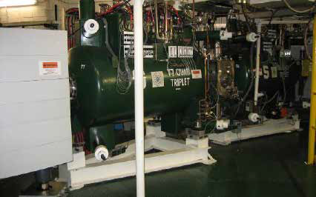 | - The Fragment Separator filters out particles that are NOT the isotope we want to study. In essence, the Separator is two magnetic spectrometers (four dipole magnets) in a row. It has high acceptance and high-efficiency transmission of specific isotopes.  - The target (deep underground) is a carbon disk rotating 5000 rpm, which spreads the beam power over a larger area and allows a location struck by beam to pass through coolant before it returns to the beam spot.  - The Separator is about 90 meters (~300 feet) long, starting deep underground by the target and curving to connect with beamlines in the experimental area. It is composed of several large dipole magnets (gray, pic on the right) that act on isotopes like prisms act on different colors of light, bending and spreading the beam particles according to their ratio of momentum (mass x velocity) over charge. Only some particles make it around the corner (a 45-degree turn) into the next beam pipe. Quadrupole magnets (green barrels), arranged in eight “triplets” (groups of three), focus the continuing beam like a lens focuses light.  - Rare isotope beam intensity is key! It is imperative that the Separator preserve as many of the desired isotope as possible while efficiently eliminating the vast majority of other isotopes from the beam. As nuclei pass through the separator, it can select one nucleus from a billion billion others. It’s like finding one specific person on a billion Earths. Includes 2x 180-ton and 2x 120-ton magnets  - There is a windowed box and camera looking in at a point on the beam line where operators can lower a fluorescent screen and establish where the beam is, size, shape, etc. During the process of “tuning”, this provides visual confirmation. The window is there so people can see the slit drives in motion.  “Tuning” to find a particular isotope is done with silicon PIN detectors (identifies element), Parallel Plate Avalanche Counters (PPACs) (measures position/angle of fragments), and a plastic scintillator (measures time-of flight and particle energy). The combination of all this information allows one to determine the mass and charge (element) for every exiting particle.

Location: N2/Cycstopper (#5 on the tour locations map)  A novel device for slowing rare isotope beams before precise measurements |  | Approval: Stefan Schwarz (10/18)
Safety/Notes: Watch for crane operation! There are often items on the floor. Flashing yellow light indicates magnetic field on – keep visitors in the doorway.
General audiences | Young students (revised language) | HS/College science students (extra info)
- This cyclotron stopper is the world’s first reverse (“backwards”) cyclotron (AKA cyclotron stopper). Instead of accelerating particles, it slows them down.  - The cyclotron stopper will be used to slow down light ions that cannot be collected efficiently in the more compact (~1m long) linear gas cells in N4. Light ions are expected to travel up to 200 meters inside. Fast ions circle in the magnetic field and spiral towards the center as they lose kinetic energy through collisions with the gas. The ions, now with much less energy, are extracted and sent to various detectors.  - Low-energy nuclei are MUCH easier to measure precisely! For instance, if you wanted to weigh yourself, you wouldn’t drive over the scale as fast as possible. We must slow the nucleus down to weigh it.  - Magnet facts: the steel yoke weighs about 170 tons and it stands 14 feet tall. The floor in N2 has been reinforced with micropilings down to bedrock to support the cyc-stopper’s weight.  - One side of the cyclotron stopper moves on rails and opens for access to the stopping chamber.  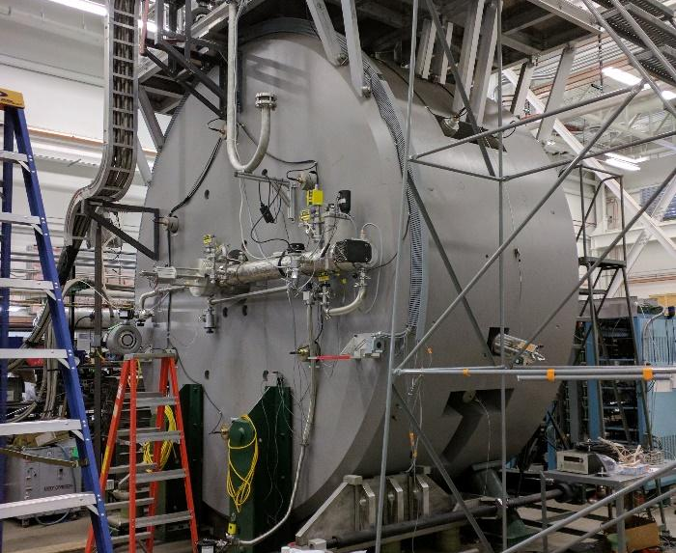  - The 14-foot tall, 170-ton cycstopper | - This cyclotron stopper is the world’s first reverse (“backwards”) cyclotron (AKA cyclotron stopper). Instead of accelerating particles, it slows them down.  - The cyclotron stopper will be used to slow down light ions that cannot be collected efficiently in the more compact (~1m long) linear gas cells in N4. Light ions are expected to travel up to 200 meters inside. Fast ions circle in the magnetic field and spiral towards the center as they lose kinetic energy through collisions with the gas. The ions, now with much less energy, are extracted and sent to various detectors that can make precise measurements on slow particles.  - Magnet facts: the steel yoke weighs about 170 tons and it stands 14 feet tall. The floor in N2 has been reinforced with pillars down to bedrock to support the cyc-stopper’s weight.  - One side of the cyclotron stopper moves on rails and opens for access to the stopping chamber. | - This is the world’s first reverse (“backwards”) cyclotron (AKA cyclotron stopper). Instead of accelerating particles, it slows them down.  - It uses a sectored magnet with a maximum magnetic field strength of 2.6 T. Contrary to other cyclotrons, it does not use RF dees to change the ions’ energy but relies on solid degraders and buffer gas inside a central chamber to stop the ions.  - The cyclotron stopper will be used to slow down light ions that cannot be collected efficiently in the more compact (~1m long) linear gas cells in N4. Light ions are expected to travel up to 200 meters inside. Fast ions circle in the magnetic field and spiral towards the center as they lose kinetic energy through collisions with the gas. The ions, now with much less energy, are extracted and sent to various detectors that can make precise measurements on slow particles.  - RF-based ion guides, so-called ion carpets and an ion conveyor, are used to center and extract the stopped ions. Prof. Morrissey’s and Bollen’s research groups have been developing RF-based ion guiding techniques over many years and used them to prepare beams for the low-energy experimental program (LEBIT, BECOLA) and ReA.  - The central chamber can be cooled to liquid-nitrogen temperature to improve cleanliness of the extracted beams.  - The cyclotron stopper can be biased up to 60kV to deliver the stopped ions as a low-energy beam (note the large green insulators).  - Magnet facts: the steel yoke weighs about 170 tons and it stands 14 feet tall. The floor in N2 has been reinforced with micropilings to support the cyc-stopper’s weight. The magnet has its own cryo-refrigerators to provide liquid helium to its two super-conducting coils, facilitating HV operation.  One side of the cyclotron stopper moves on rails and opens for access to the stopping chamber.

Location: N4/Stopped Beam Area (#6 on the tour locations map)  A variety of linear gas stoppers |  | Approval: Chandana Sumithrarachchi (TBD)
Safety/Notes: This room is often actively under construction, be aware of personnel, equipment and materials! Yellow light indicates magnetic field is on - do not bring visitors into the vault! This room is normally blocked off - if you want to stop here, you will likely have to stand outside. Tour guides have permission to bypass the strap across the door, replacing it when done. Stay on the platform!
General audiences | Young students (revised language) | HS/College science students (extra info)
- Some experiments require a low-energy beam to perform a precise measurement. This vault is where beam nuclei can be slowed down to velocities similar to the molecules in air and then sent on for an experiment or reacceleration.  - Three beam lines are installed in the room with different capabilities to slow down and collect the fast beams for new experiments with stopped nuclei and reaccelerated beams!  - Stopping the rare isotopes allows researchers to make more careful measurements (e.g. measuring their mass - you wouldn’t try to weigh yourself by driving over the scale at 70 mph! Alternatively: it’s hard to weigh a cat when it won’t stop moving.)  - What you can see are magnets – the gas stoppers themselves are blocked from view. There are 2 gas cells.  - Slowing down the fast ions with helium gas can be compared to slowing down a speeding bullet as it flies through a giant cloud of flying gnats. Every collision takes a tiny energy and eventually after billions and billions of collision the bullet will stop.  - The platform is at 30 kV potential, which also pushes stopped ions out of the far corner to the new precision measurements area and the reaccelerator.  - The Advanced Cryogenic gas cell has the advantage of fewer reactions with impurities. You can just see it over the magnets. | - Some experiments require a low-energy beam to perform a precise measurement. This vault is where beam nuclei can be slowed down to velocities similar to the molecules in air and then sent on for an experiment or reacceleration.  - Three beam lines are installed in the room with different capabilities to slow down and collect the fast beams for new experiments with stopped nuclei and reaccelerated beams!  - Stopping the rare isotopes allows researchers to make more careful measurements (e.g. measuring their mass - you wouldn’t try to weigh yourself by driving over the scale at 70 mph! Alternatively: it’s hard to weigh a cat when it won’t stop moving.)  - What you can see are magnets – the gas stoppers themselves are blocked from view. There are 2 gas cells.  - Slowing down the fast ions with helium gas can be compared to slowing down a speeding bullet as it flies through a giant cloud of flying gnats. Every collision takes a tiny energy and eventually after billions and billions of collision the bullet will stop.  - The platform is at 30 kV potential, which also pushes stopped ions out of the far corner to the new precision measurements area and the reaccelerator.  - The Advanced Cryogenic gas cell has the advantage of fewer reactions with impurities. You can just see it over the magnets. | - Some experiments require a low-energy beam to perform a precise measurement. This vault is where beam nuclei can be slowed down to velocities similar to the molecules in air and then sent on for an experiment or reacceleration.  - Note that gas stoppers reduce incoming nuclei to “thermal energies”, equivalent to the speeds of particles moving in room-temperature air. This is still hundreds of meters per second!  - Three beam lines (AA, AB, AC) are installed in the room with different capabilities to slow down and collect the fast beams for new experiments with stopped nuclei and reaccelerated beams!  - Stopping the rare isotopes allows researchers to make more careful measurements (e.g. measuring their mass - you wouldn’t try to weigh yourself by driving over the scale at 70 mph! Alternatively: it’s hard to weigh a cat when it won’t stop moving.)  - What you can see are magnets – the gas stoppers themselves are blocked from view. There are 2 gas cells. The ions slow down by passing through metal plates a few mm thick and then go into 50-75 torr of 99.9999% helium gas (which is difficult to ionize, a benefit). Escaping helium gives the stopped ions a final push out of the 1.3 mm hole. 5% extraction efficiency is representative of normal operating conditions. The minimum extraction time: 63 ms.  - Slowing down the fast ions with helium gas can be compared to slowing down a speeding bullet as it flies through a giant cloud of flying gnats. Every collision takes a tiny energy and eventually after billions and billions of collision the bullet will stop.  - The platform is at 30 kV potential, which also pushes stopped ions out of the far corner to the new precision measurements area and the reaccelerator.  - The Advanced Cryogenic gas cell has the advantage of fewer reactions with impurities. It uses RF surfing, and has a faster extraction/shorter drift time (~10 ms?). It should have higher efficiency (>5%). You can just see it over the magnets.
Location: Low-Energy Area/Precision Measurements/LEBIT (#7 on the tour locations map)  The Low Energy Beam Ion Trap (LEBIT), a detector for measuring the mass of nuclei |  | Approval: Ryan Ringle (10/18)
Safety/Notes: View LEBIT by looking in the window on the southern door facing the East High Bay (near “7” on the map)
General audiences | Young students (revised language) | HS/College science students (extra info)
- LEBIT has a superconducting magnet (gray barrel with spartan “S”, note the yellow light on top indicating strong magnetic field) where previously-slowed & bunched nuclei are trapped in a circular orbit.  - It’s probably the strongest magnet you’ll probably ever see (9.4 T, 94000 gauss, about 200,000 times the strength of the Earth’s magnetic field), and it’s always on (note yellow light above it), but it’s well shielded. NOTE: you can feel the field near where the beamline enters the barrel, so beware!  - You can measure mass by measuring the frequency of its orbit (like RPM) inside the magnetic trap: heavy ions are slower.  - LEBIT can measure the mass of a nucleus in less than one second with a precision of one part in 100 million; like weighing an entire jumbo jet and telling how much change is in the pilot’s pocket.  - Once NSCL staff got the current (about 100 amps) running in the superconducting coil inside, they unplugged it. The current is still going! It’s superconducting, so there’s no reason for the current to stop as long as the niobium wire is kept cold. LEBIT can operate for several thousand years before recharging. It is essentially the best battery you’ll ever see.  - Helium and nitrogen gas pressure release valves allow vaporized LHe and LN2 to escape. Oxygen sensors in the room tell you if too much nitrogen is escaping (because N2 displaces oxygen and creeps along the floor, making it hazardous). Any ice on the LN2 pipes is just humidity in the air freezing onto the cold surface. | - LEBIT has a superconducting magnet (gray barrel with spartan “S”, note the yellow light on top indicating strong magnetic field) where previously-slowed & bunched nuclei are trapped in a circular orbit.  - You can measure mass by measuring the frequency of its orbit (like RPM) inside the magnetic trap: heavy ions are slower.  - LEBIT can measure the mass of a nucleus in less than one second with a precision of one part in 100 million; like weighing an entire jumbo jet and telling how much change is in the pilot’s pocket.  - It’s the strongest magnet you’ll probably ever see (9.4 T, 94000 gauss, about 200,000 times the strength of the Earth’s magnetic field), and it’s always on (note yellow light above it), but it’s well shielded. NOTE: you can feel the field near where the beamline enters the barrel, so beware!  - Once NSCL staff got the current (about 100 amps) running in the superconducting coil inside, they unplugged it. The current is still going! It’s superconducting, so there’s no reason for the current to stop as long as the niobium wire is kept cold. LEBIT can operate for several thousand years before recharging. It is essentially the best battery you’ll ever see.  - Helium and nitrogen gas pressure release valves allow vaporized LHe and LN2 to escape. Oxygen sensors in the room tell you if too much nitrogen is escaping (because N2 displaces oxygen and creeps along the floor, making it hazardous). Any ice on the LN2 pipes is just humidity in the air freezing onto the cold surface.  We’ve recently added a 7 T magnet to the beam line, but you can’t see it from the doors. This houses the new Single Ion Penning Trap (SIPT) which uses a different detection technique. Essentially it picks up the signal from a single trapped ion on the trap electrodes. To detect this tiny signal a superconducting resonant circuit is used, so the trap and detection electronics are cooled to liquid helium temperature (~4K). SIPT can measure isotopes delivered at the rate <1/day, drastically improving the reach of the high-precision mass measurement program.  Someone may ask why don’t you just use SIPT for every measurement, but it’s best suited for high-impact cases. The measurement method isn’t as flexible as our original trap. The original trap can move from mass 20 to 200 in a couple of seconds with simple adjustment. Using SIPT we have to change out the resonator circuit if we want to measure a significantly different mass range. | - LEBIT has a superconducting magnet (gray barrel with spartan “S”, note the yellow light on top indicating strong magnetic field) where previously-slowed & bunched nuclei are trapped in a circular orbit.  - You can measure their mass by measuring the frequency of their orbit (like RPM) inside the magnetic (+electrostatic= Penning) trap: heavy ions are slower. Typical frequencies measured are 1-10 MHz.  - Cyclotron frequency is a simple calculation: ω_{c} = qB/m (cyclotron frequency is equal to charge*B-field/mass)  - The mass is measured by probing the ions’ specific (cyclotron) frequency with a radio frequency electric field, seeking the resonant frequency that will eject it from the trap. This technique works best for single trapped ions.  - LEBIT can measure the mass of a nucleus to one part in 100 million; like weighing an entire jumbo jet and telling how much change is in the pilot’s pocket.  - Can measure isotopes with half lives down to the ms range. Stopping in the helium gas cell takes 10-100 ms. Cooling/bunching the beam (converting a continuous beam of nuclei to bunches) takes 5-30 ms. Time spent measuring in Penning trap takes between a few ms to a few s.  - World record for precisely measuring mass of short-lived isotope w/ a Penning Trap like LEBIT at TRIUMF: Lithium-11 (half life 10 ms)!  - Mass measurement results can have implications for astrophysics, the r-process path, nuclear structure and fundamental interactions.  - It’s the strongest magnet you’ll probably ever see (9.4 T, 94000 gauss, about 200,000 times the strength of the Earth’s magnetic field), and it’s always on (note yellow light above it), but it’s well shielded. NOTE: you can feel the field near where the beamline enters the barrel, so beware!  - Once current (about 100 amps) was running in the superconducting coil inside, they unplugged it. The current is still going! It’s superconducting, so there’s no reason for the current to stop as long as the niobium wire is kept cold. LEBIT can operate for several thousand years before recharging. It is essentially the best battery you’ll ever see.  Helium and nitrogen gas pressure release valves allow vaporized LHe and LN2 to escape. Oxygen sensors in the room tell you if too much nitrogen is escaping (because N2 displaces oxygen and creeps along the floor, making it hazardous). Any ice on the LN2 pipes is just humidity in the air freezing onto the cold surface.

Location: Low-Energy Area/Beam Cooler Laser Spectroscopy (BECOLA) (#7 on the tour locations map)  BECOLA performs spectroscopy on rare isotopes with a laser tuned to different energies/colors. |  | Approval: Ryan Ringle (10/18)
Safety/Notes: View BECOLA by looking in the window from the main hallway (just west of receiving)
General audiences | Young students (revised language) | HS/College science students (extra info)
- BECOLA stands for BEam COoler and LAser spectroscopy. BECOLA shoots laser light into very “cold” beams of nuclei to study the nuclear structure and fundamental symmetries.  - Depending on its electron configuration, an element reacts to a certain color of laser light and fluoresces as a response. The color to which the atom reacts depends on the element (each has a “fingerprint” spectrum) and even among isotopes of an element there is subtle variation of the light color absorbed. Researchers use the slight changes of light color/energy necessary for the atom’s reaction to deduce information about nuclear structure and fundamental symmetries. BECOLA can detect light wavelength change of 0.00001%. For comparison, the human eye can detect a change of 0.1%  - BECOLA can measure nuclear structure, such as the “size” of a nucleus; a charge radius. BECOLA can measure a nuclear radius of a few femtometer (10⁻¹⁵ m), and distinguish radius variations between isotopes that are hundreds of times smaller.  - The laser system consists of a 15 W green laser to pump a Titanium:Sapphire ring laser (~2 W, 700-1000 nm). The light from the Ti:S laser can be frequency doubled to generate second-harmonic light (~250 mW, 350 – 500 nm). Laser light is transported through an optical fiber or vacuum tube about 25 meters to the BECOLA beam line. | - BECOLA stands for BEam COoler and LAser spectroscopy. BECOLA shoots laser light into very “cold” beams of nuclei to study the nuclear structure and fundamental symmetries.  - Depending on its electron configuration, an element reacts to a certain color of laser light and fluoresces as a response. The color to which the atom reacts depends on the element (each has a “fingerprint” spectrum) and even among isotopes of an element there is subtle variation of the light color absorbed. Researchers use the slight changes of light color/energy necessary for the atom’s reaction to deduce information about nuclear structure and fundamental symmetries. BECOLA can detect light wavelength change of 0.00001%. For comparison, the human eye can detect a change of 0.1%  - BECOLA can measure nuclear structure, such as the “size” of a nucleus; a charge radius. BECOLA can measure a nuclear radius of a few femtometer (10⁻¹⁵ m), and distinguish radius variations between isotopes that are hundreds of times smaller.  - The laser system consists of a 15 W green laser to pump a Titanium:Sapphire ring laser (~2 W, 700-1000 nm). The light from the Ti:S laser can be frequency doubled to generate second-harmonic light (~250 mW, 350 – 500 nm). Laser light is transported through an optical fiber or vacuum tube about 25 meters to the BECOLA beam line.  Additional info  Experimenters can also produce polarized beam (all spins are pointing at the same direction) using optical pumping technique with circularly polarized laser light. The bike rim coils along the beam line produce magnetic field to maintain the polarization. The polarized beam is required for the beta-particle-detecting nuclear magnetic resonance (β NMR) technique, which has much higher sensitivity than the conventional NMR due to the polarization and beta particle detection. This technique may be applied to rates as low as ~ 100 ions per second as well.  The BECOLA facility includes a Penning Ionization Gauge (PIG) offline ion source, a discharge sputtering source that can generate many stable isotopes including refractory elements (transition metals). Experimenters can use beams produced at the PIG source offline to develop the best laser excitation schemes for spectroscopy in future rare isotope experiments. | - BECOLA stands for BEam COoler and LAser spectroscopy. BECOLA shoots laser light into very “cold” beams of nuclei to study the nuclear structure and fundamental symmetries.  - Depending on its electron configuration, an element reacts to a certain color of laser light and fluoresces as a response. The color to which the atom reacts depends on the element (each has a “fingerprint” spectrum) and even among isotopes of an element there is subtle variation of the light color absorbed. Researchers use the slight changes of light color/energy necessary for the atom’s reaction to deduce information about nuclear structure and fundamental symmetries. BECOLA can detect light wavelength change of 0.00001%. For comparison, the human eye can detect a change of 0.1%  - BECOLA can measure nuclear structure, such as the “size” of a nucleus; a charge radius. BECOLA can measure a nuclear radius of a few femtometer (10⁻¹⁵ m), and distinguish radius variations between isotopes that are hundreds of times smaller.  - Beams from NSCL gas stopper are delivered to the BECOLA beam cooler/buncher. The cooler/buncher is a device that improves the quality of a rare isotope beam from the gas stopper, meaning it emits beams with a small energy spread, small divergence, small diameter and so forth.  - The laser system consists of a 15 W green laser to pump a Titanium:Sapphire ring laser (~2 W, 700-1000 nm). The light from the Ti:S laser can be frequency doubled to generate second-harmonic light (~250 mW, 350 – 500 nm). Laser light is transported through an optical fiber or vacuum tube about 25 meters to the BECOLA beam line, introduced via a laser window on the 2-way bend using optic components on the breadboard.  - Resulting fluorescence is collected with a detection system using an ellipsoidal mirror. The laser light and beam pass through one of the focal points of the ellipse. Any fluorescence emitted at the focal point is re-focused at the other focal point, where a light detector is placed. This is similar to a parabolic antenna for satellite TV, efficiently collecting signal.  - The fluorescence detection system is turned on only when there are beam bunches from the cooler/buncher, increasing signal to noise ratio. The technique makes it possible for experimenters to perform measurements with incoming ion beam rates as low as ~ 100 ions per second, which makes more (and rarer) isotopes accessible to the researcher.

Location: S3/S800 Spectrograph (#8 on the tour locations map)  A detector for measuring nuclear structure |  | Approval: Jorge Pereira Conca (TBD)
Safety/Notes: Don’t lean over the rail! Don’t take groups downstairs; however, if you must, advise them to watch their step because it is steep! They should wear shoes without heels. The downstairs is not usually surveyed either! Notify visitors who don’t like heights that they can wait off the catwalk.
General audiences | Young students (revised language) | HS/College science students (extra info)
- The S800 spectrograph is 3 stories high, 300 tons, designed to detect fragments coming from a collision between the rare isotope beam and a thin foil target. This detector is so versatile, over one-third of the experiments performed at NSCL use it!  - The basic idea of the S800 is that it allows the measurement of the velocity and angles of the fragments with great accuracy.  - The S800 acts much like the A1900 in that its two brown dipole magnets filter out many products and allow only the fragments of interest to reach the white detector box at top. By establishing the identity of those particles, their energies, and their trajectories, researchers can model what the rare isotopes were like before the collision: the structure of the nucleus.  - October 2016: work done on S800 + GRETINA shows Si-34 is a “bubble” nucleus, no protons in center! First discovery of this structure, which had been predicted for 40 years.  - To check different scattering angles of post-collision fragments, the S800 can rotate over 150°, although this is rarely used nowadays; the particles in the beam are usually much heavier than those in the target and thus tend to continue their forward-directed motion without being deflected much. | - The S800 spectrograph is 3 stories high, 300 tons, designed to detect fragments coming from a collision between the rare isotope beam and a thin foil target. This detector is so versatile, over one-third of the experiments performed at NSCL use it!  - The basic idea of the S800 is that it allows the measurement of the velocity and angles of the fragments with great accuracy.  - The S800 acts much like the A1900 in that its two brown dipole magnets filter out many products and allow only the fragments of interest to reach the white detector box at top. By establishing the identity of those particles, their energies, and their trajectories, researchers can model what the rare isotopes were like before the collision: the structure of the nucleus.  - October 2016: work done on S800 + GRETINA shows Si-34 is a “bubble” nucleus, no protons in center! First discovery of this structure, which had been predicted for 40 years.  - To check different scattering angles of post-collision fragments, the S800 can rotate over 150°, although this is rarely used nowadays; the particles in the beam are usually much heavier than those in the target and thus tend to continue their forward-directed motion without being deflected much. | - The S800 spectrograph is 3 stories high, 300 tons, designed to detect fragments coming from a collision between the rare isotope beam and a thin foil target. This detector is so versatile, over one-third of the experiments performed at NSCL use it!  - The basic idea of the S800 is that it allows the measurement of the velocity and angles of the fragments with great accuracy. The S800 combines two key factors to achieve its performance:  - High resolution (at best 0.01% of the particle’s energy), meaning it is capable of distinguishing between two particles of only slightly different energies. This is equivalent to 0.005% of the velocity, like whether a car was moving 50 or 50.0025 mph.  - Large acceptance, meaning it collects and measures inside a large momentum range (~5% of the central energy) and angular range of the particles after they have reacted with the target.  - The S800 acts much like the A1900 in that its two brown dipole magnets filter out many products and allow only the fragments of interest to reach the white detector box at top. By establishing the identity of those particles, their energies, and their trajectories, researchers can model what the rare isotopes were like before the collision: the structure of the nucleus.  - Particles are detected (tracked) in 2 focal plane detectors placed inside the detector box. The position in each detector is determined, and from those two positions, the angle of the track. The angle and position are used to calculate (raytrace) the velocity and angles of the particles just after the collision.  - The detector box contains a scintillator used to time the particle (TOF → mass), and measure the amount of energy lost in material, an ion chamber to also measure ΔE (→ proton number), and hodoscope to measure particle energy. With this information, the particle type (charge & mass) is determined.  - Using another detector around the collision point (target) at the bottom, one can correlate data with the detected particles at the top to get more information. The Segmented Germanium Array (SeGA), GRETINA, HiRA and LENDA have been employed there to collect gamma rays, neutrons, or charged particles from nuclei that are excited in the reaction.  - October 2016: work done on S800 + GRETINA shows Si-34 is a “bubble” nucleus, no protons in center! First discovery of this structure, which had been predicted for 40 years.  - To check different scattering angles of post-collision fragments, the S800 can rotate over 150°, although this is rarely used nowadays; the particles in the beam are usually much heavier than those in the target and thus tend to continue their forward-directed motion without being deflected much.
Location: HRS Vault (#10 on the tour locations map)  The High Rigidity Spectrometer (HRS) can measure mass and structure of many r-process isotopes |  | Approval: Ting Xu
Safety/Notes:
General audiences | Young students (revised language) | HS/College science students (extra info)
 | 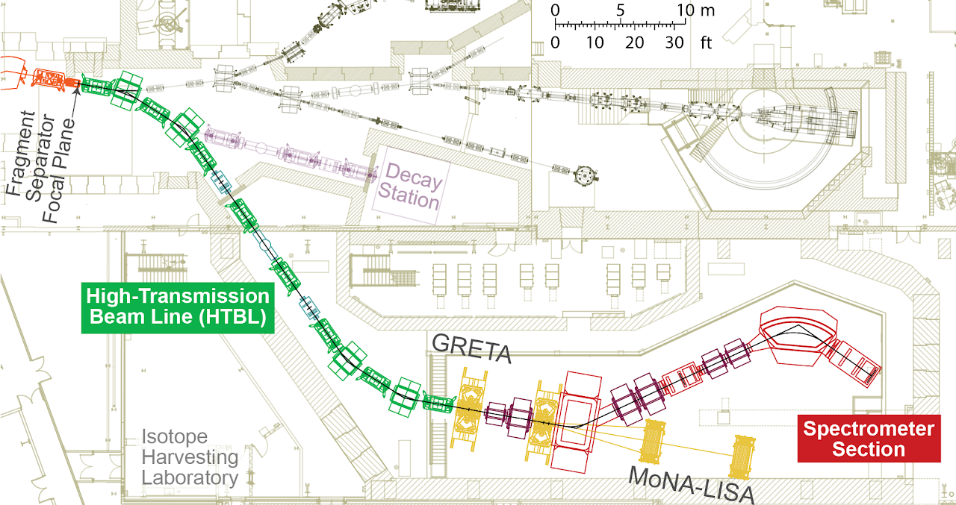 | - The 8 Tm bending power of the proposed HRS matches the rigidities at which rare isotopes will be produced at FRIB, even with the envisioned FRIB upgrade to 400 MeV/u. This will enable the most sensitive experiments across the entire chart of nuclei, thereby enabling experiments with the most neutron-rich nuclei available at FRIB. In combination with the ability to use thicker reaction targets at the higher rigidity, gain factors in luminosity of 2 to 100 will be achieved for over 90% of experiments with neutron-rich isotopes  - These gains are over what will be possible with existing spectrometers at NSCL (S800 and Sweeper) that have a maximum rigidity of 4 Tm. The largest luminosity gains are achieved for the most neutron-rich species, including those in the path of the astrophysical r-process (rapid neutron capture process) for which gains in luminosity by a factors of 5-20 can be achieved.  - The HRS consists of two main elements: the High-Transmission Beam Line (HTBL) and the Spectrometer Section. Rare isotopes beams are transported from the FRIB fragment separator through the HTBL to the target position at the HRS. The first element of the HRS after the target station is the sweeper dipole, which diverts charged particles toward a focusing beam line that transports particles to the spectrometer dipoles and the focal plane detectors. The spectrometer dipoles provide the precise exit channel characterization with momentum and particle identification resolutions required for the broad scientific program with the HRS.  - Also shown in the figure are the Gamma-Ray Energy Tracking Array (GRETA) and the Modular Neutron Array (MoNA-LISA). There are many other state-of-the-art detectors that have been developed by the User Community that will be used in combination with the HRS to achieve the scientific objectives of FRIB.

Location: ReA3 High Bay (#13 on the tour locations map)  Detectors for reaccelerated beams; nuclear astrophysics experiments; JENSA and SECAR |  | Approval: Hendrik Schatz
Safety/Notes: Try to leave a path for thru foot traffic. No real safety issues.
General audiences | Young students (revised language) | HS/College science students (extra info)
- Low-energy (stellar) beams feed into this room from ReA3 on the other side of the far wall. The many experimental stations here study nuclear astrophysics (how nuclei behave in stars).  - Jet Experiments in Nuclear Structure and Astrophysics (JENSA) contains the world’s densest He gas jet with 10¹⁹ nuclei/cm².  - JENSA experiments will directly measure astrophysical reactions of radioactive nuclei with hydrogen or helium at the same collision energy that particles have inside stellar explosions e.g. X-ray bursts and Novae (10⁸ - 10⁹ degrees)  - Jet inlet pressure is maintained by large compressor is up to 40 Atmospheres. The connection to the high vacuum beamlines is made with a series of differential pumping stages where 13 large pumps (each named after a dwarf in The Hobbit) bring the pressure stepwise down to high vacuum. All gas is recirculated in a closed system so we can use expensive gases like ³He (filling the system is about $100k)  - SEparator for CApture Reactions (SECAR) can directly measure astrophysical reactions where a radioactive nucleus captures either a proton or a helium nucleus, emitting a gamma ray. The purpose of SECAR is to separate the beam from the capture reaction product, which can then be counted in detectors at the far end of SECAR. SECAR is expected to detect reactions that occur with rates a slow as one per day.  - SECAR will be sensitive to extremely weak reactions (p,γ) and (α,γ) in the rp process that are important to understand X-ray bursts, Novae, Supernovae, Supermassive Stars, and other more exotic phenomena. | - Low-energy (stellar) beams feed into this room from ReA3 on the other side of the far wall. The many experimental stations here study nuclear astrophysics (how nuclei behave in stars).  - Jet Experiments in Nuclear Structure and Astrophysics (JENSA) contains the world’s densest He gas jet with 10¹⁹ nuclei/cm².  - JENSA experiments will directly measure astrophysical reactions of radioactive nuclei with hydrogen or helium at the same collision energy that particles have inside stellar explosions e.g. X-ray bursts and Novae (10⁸ - 10⁹ degrees)  - Jet inlet pressure is maintained by large compressor is up to 40 Atmospheres. The connection to the high vacuum beamlines is made with a series of differential pumping stages where 13 large pumps (each named after a dwarf in The Hobbit) bring the pressure stepwise down to high vacuum. All gas is recirculated in a closed system so we can use expensive gases like ³He (filling the system is about $100k)  - SEparator for CApture Reactions (SECAR) can directly measure astrophysical reactions where a radioactive nucleus captures either a proton or a helium nucleus, emitting a gamma ray. The purpose of SECAR is to separate the beam from the capture reaction product, which can then be counted in detectors at the far end of SECAR. SECAR is expected to detect reactions that occur with rates a slow as one per day.  - SECAR will be sensitive to extremely weak reactions that are important to understand X-ray bursts, Novae, Supernovae, Supermassive Stars, and other more exotic phenomena. | - Jet Experiments in Nuclear Structure and Astrophysics (JENSA) is designed by Colorado School of Mines and Oak Ridge Nat Lab, funded by DOE and JINA. JENSA contains the world’s densest He gas jet with 10¹⁹ nuclei/cm².  - JENSA experiments will directly measure astrophysical reactions of radioactive nuclei with hydrogen or helium at the same collision energy that particles have inside stellar explosions e.g. X-ray bursts and Novae (10⁸ - 10⁹ degrees)  - The radioactive beam from ReA3 hits a 4mm stream of gas (the jet), and reaction products such as protons or helium nuclei are detected by surrounding Si detectors. Reactions that emit only gamma-rays will need a gamma ray detection array that is currently under construction and the SECAR recoil separator.  - Jet inlet pressure is maintained by large compressor is up to 40 Atmospheres. The connection to the high vacuum beamlines is made with a series of differential pumping stages where 13 large pumps (each named after a dwarf in The Hobbit) bring the pressure stepwise down to high vacuum. All gas is recirculated in a closed system so we can use expensive gases like ³He (filling the system is about $100k)  - SEparator for CApture Reactions (SECAR) can directly measure astrophysical reactions where a radioactive nucleus captures either a proton or a helium nucleus, emitting a gamma ray.  - SECAR is coupled with JENSA, where the radioactive beam passes through a gas jet. Both the unreacted beam and the few heavier nuclei produced by capture reactions in the target enter SECAR. The purpose of SECAR is to separate the beam from the capture reaction product, which can then be counted in detectors at the far end of SECAR. SECAR is expected to detect reactions that occur with rates a slow as one per day.  - SECAR consists of four separation stages – the first and last separate charge states using dipole magnets, while the middle two use a Velocity Filter to separate by velocity. SECAR Velocity Filters have electrodes charging up to +/-250 kV, creating an electric field that is perpendicular to a dipole magnetic field. Both fields steer particles horizontally in opposite directions, but the forces cancel for the desired velocity.  - All magnets are room temperature magnets SECAR is designed by JINA-CEE scientists at Notre Dame, built by a collaboration with funding from DOE Office of Science and the NSF.

Location: ReA12 High Bay/ReA6 Vault/SOLARIS (#14 on the tour locations map)  A detector for measuring nuclei exiting the ReA6 reaccelerator |  | Approval: Ana Henriques (TBD)
Safety/Notes: Watch for crane operation! Gates require card activation, which requires ReA6 access training. Flashing yellow light next to the cylindrical magnet indicates magnetic field on - keep visitors behind the blue/white stripe on the floor.
General audiences | Young students (revised language) | HS/College science students (extra info)
- SOLARIS is a big cylindrical magnet, much like an MRI you would find in a hospital.  - Typical field strength can be varied from 2-4 Tesla (50,000x the Earth’s magnetic field) uniformly spread over large volume.  - Researchers can put different containers inside the magnet to measure the various things that nuclei do when they hit each other.  - Sometimes they put a tube of helium inside, and when fast nuclei come in from the accelerator, they bounce off of the helium and knock off electrons. Catching those electrons lets the detector track nuclei in 3D!  - Research here allows better understanding of nuclear reactions in stars and nuclear energy levels.  - This detector was produced through a collaboration with Argonne National Laboratory, just outside of Chicago. Researchers from many labs/schools planned for over a decade to produce a new and useful tool that would let them do these measurements at FRIB!  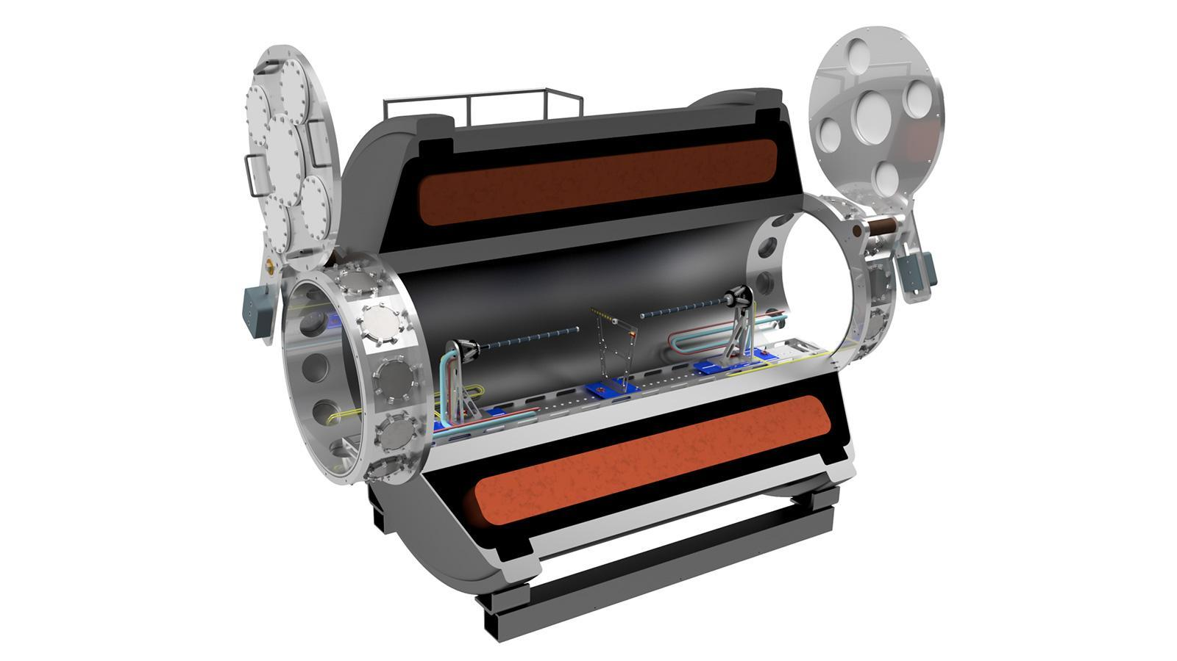  Conceptual design of the vacuum-mode silicon array setup inside SOLARIS | - SOLARIS is a big cylindrical magnet, much like an MRI you would find in a hospital.  - Typical field strength can be varied from 2-4 Tesla (50,000x the Earth’s magnetic field) uniformly spread over large volume.  - Researchers can put different containers inside the magnet to measure the various things that nuclei do when they hit each other.  - Sometimes they put a tube of helium inside, and when fast nuclei come in from the accelerator, they bounce off of the helium and knock off electrons. Catching those electrons lets the detector track nuclei in 3D!  - Research here allows better understanding of nuclear reactions in stars and nuclear energy levels.  - The AT-TPC discovered an incredibly rare radioactive decay: a nucleus with very few protons actually released one of them, which shouldn’t happen!  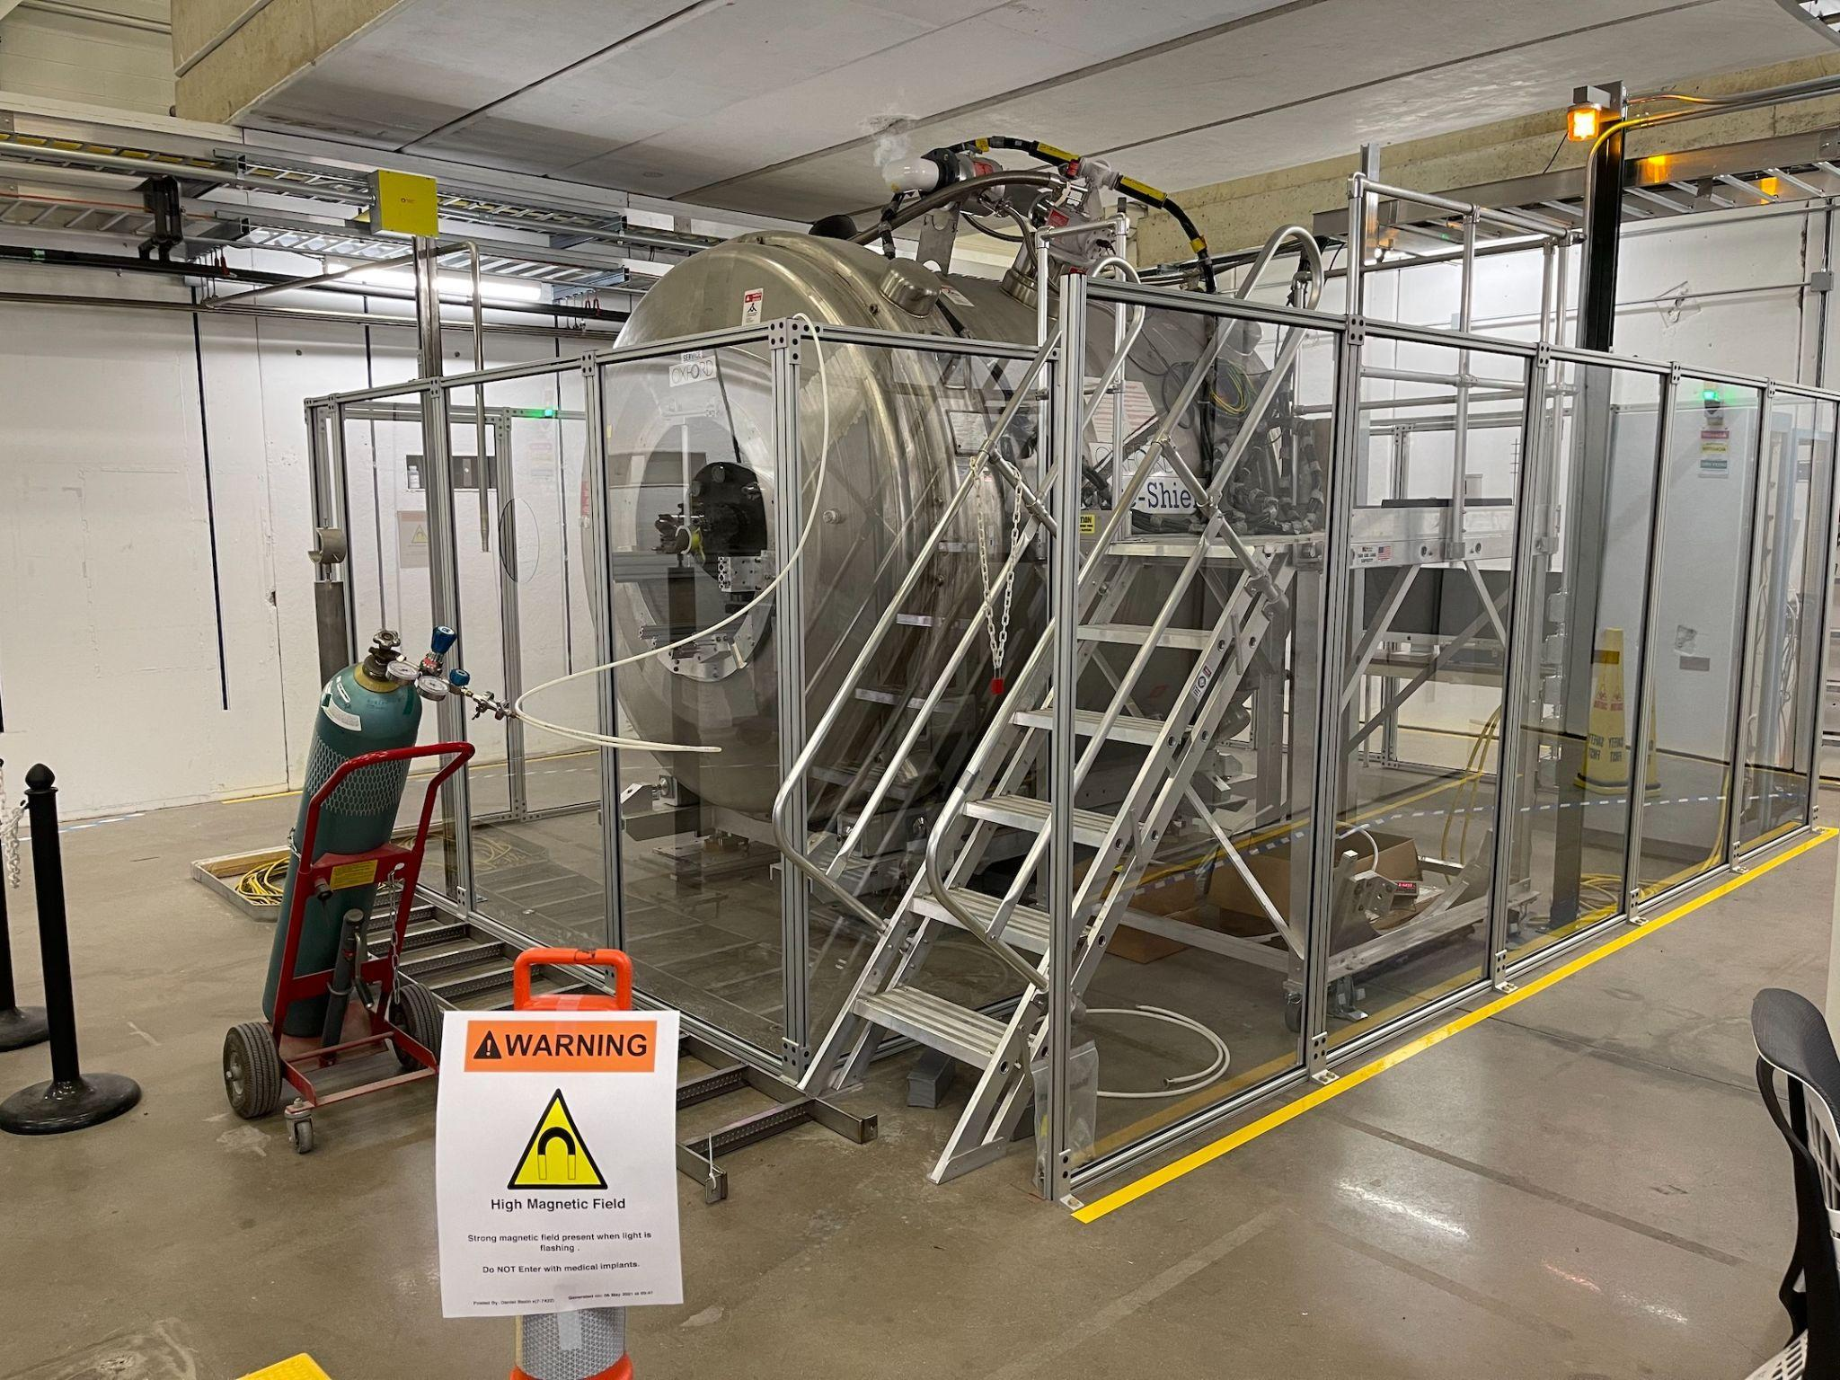  The SOLARIS solenoid magnet set up in ReA6 High Bay | - SOLARIS is a big cylindrical magnet, much like an MRI you would find in a hospital.  - Typical field strength can be varied from 2-4 Tesla (50,000x the Earth’s magnetic field) uniformly spread over large volume.  - Two modes of operation:  - Vacuum chamber inside, uses on-axis array of silicon detectors for hi-res study of reactions. Various targets and detectors can be inserted in the middle of the solenoid magnet.  - AT-TPC mode uses a gas chamber as a target and detection material - as star-like nuclei enter, they react with target gas (usually helium, as they would in a star). The products ionize many electrons, which drift under a voltage difference until they strike the detector pad at the end of the cylinder. Using location and time of electron arrivals, this tracks particles in 3D! The strong magnetic field causes those particles to travel in a helix/spiral which is distinct for each different type of particle, so they’re easy to identify!  - Research here allows better understanding of nuclear reactions in stars and nuclear energy levels.  - Single-nucleon transfer reactions (trading one proton or neutron between nuclei) measured here will help us understand nuclear structure and the energy of each particle.  - The AT-TPC discovered an incredibly rare radioactive decay: proton emission after a beta-minus decay in beryllium-11. Neutron-rich nuclei don’t usually emit protons!

Location: FRIB scale model (between the Auditorium and Seminar Room on the tour locations map)  These two models (one of the entire building, one of the linac addition) are a great way to orient visitors |  | Approval:
Safety/Notes: No safety issues. This is a good location to visit when many vaults are closed, or you’re waiting for another group to move on
General audiences | Young students (revised language) | HS/College science students (extra info)
Full building model
- Point out where visitors entered the lobby.
- Trace the beam from the ion source (back left corner) to the target (back right corner) to the experimental areas (tall building in center).
- Identify the SRF High Bay (left side, near the Wharton Center) where accelerating cavities are cleaned, conditioned, tested, and assembled into cold masses for installation in a cryomodule.
Linac building model
- Again, you can trace the beam from the ion source, through three linac segments deep underground, to the target, then up through the preseparator to the experimental areas.
- Note the black “dirt” between surface building (where the racks are) and the linac tunnel. This provides radiation shielding, along with the concrete of the structure. RF power is carried from the rack room through tubes to the tunnel.
- Point out the cryomodule boxes in the linac. There are six types of cryomodules containing four types of SRF cavities.
- The final FRIB building is over 500,000 sq. ft., double the size of NSCL before it.
- Planning for a next-gen accelerator lab started in 1999, we won the $730 million project from US Department of Energy in 2008, construction started in 2014, and operation will begin in Feb/Mar 2022.

Location: K500 wooden model (between the Auditorium and Seminar Room on the tour locations map)  A 1:1 scale model of the beam chamber inside the world’s first superconducting cyclotron |  | Approval:
Safety/Notes: No safety issues. This is a good location to visit when many vaults are closed, or you’re waiting for another group to move on
General audiences | Young students (revised language) | HS/College science students (extra info)
 | 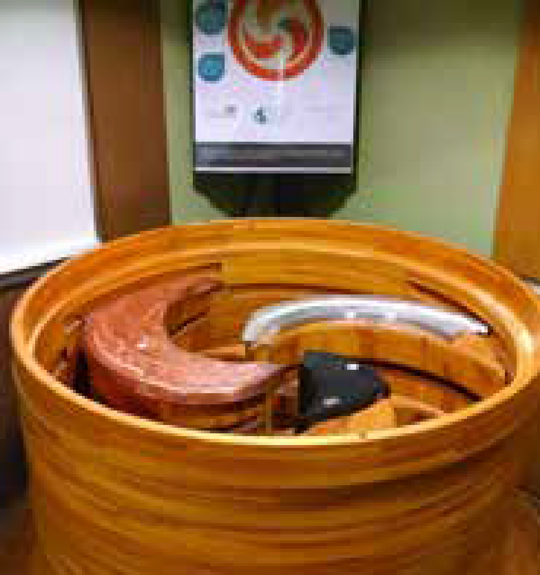 | - The K500 was designed long before Computer Aided Design (CAD) was available. A wooden model was constructed first in the 1970s to ensure that the parts would fit correctly!  - It is a full-scale model of the interior shows the fan-shaped Dees (radio-frequency high voltage for acceleration) and Hills (high magnetic field regions between the Dees where acceleration takes place). Dee shape helps focus the beam in the vertical direction.  - The black trim coils are like fine tuners to make the magnetic field isochronous (the particles stay in phase with the accelerating electric field)  - The copper Hill liner keeps the RF contained in the beam chamber  - The aluminum Beam probe track resides inside of a Dee and follows its shape. It provides a way to carry a camera or beam current monitor (on a little train of cars) to observe the beam as it moves out in radius (i.e., higher energy)  - The 20-mile long coil of niobium wire would wrap around the outside of this model. This superconducting electromagnet, cooled with liquid helium, confines the beam inside the plane of the cyclotron, while the dee shape focusses the beam in the vertical direction.  When the K500 produced beam in 1982, it became the world’s first superconducting cyclotron. Nuclei orbited inside ~250 times before exiting at 0.15c or 30,000 miles/second.

Location: Variable! These detectors may be set up in different places.  SeGA and GRETINA are versatile gamma-ray detectors sometimes used to complement another detector |  | Approval: Dirk Weisshaar (SeGA & GRETINA)
Safety/Notes:
General audiences | Young students (revised language) | HS/College science students (extra info)
- The Segmented Germanium Array (SeGA) is one of many gamma-ray detectors at FRIB. After the nucleus is excited, it will often de-excite by emitting energy in the form of high-energy light: gamma rays. With arrays of gamma-ray detectors, this light can be collected to learn about the properties of that rare nucleus. The detectors at the NSCL are unique for detecting gamma rays from very rare nuclei that travel at very high velocities.
- The segmented germanium array (SeGA) allows “high resolution” in-beam γ-ray spectroscopy of intermediate- energy beams from the Coupled Cyclotrons. Each of the eighteen detectors in the array is a single-crystal 75% relative-efficiency germanium counter with the outer surface electronically divided into 32 segments. By using the segment information, the interaction of the γ-ray can be localized within the detector, therefore reducing the uncertainty in the Doppler correction due to the finite opening angle of the detector. A detector frame is available and allows the detectors to be placed at several distances, so the experimentalist can decide on the compromise between efficiency and resolution for their particular needs. The standard configuration is 18 detectors at 20 cm, which gives an approximate 3% photo peak efficiency at 1.3 MeV with about 2% in-beam energy resolution. The detectors are also available for stopped beam experiments such as β-delayed γ-ray decay studies. (from NSCL website)
- The Gamma-Ray Energy Tracking IN Array (GRETINA) is built from large crystals of hyper-pure germanium and will be the first detector to use the recently developed concept of gamma-ray energy tracking. GRETINA consists of 28 highly segmented coaxial germanium crystals. Each crystal is segmented into 36 electrically isolated elements and four crystals are combined in a single cryostat to form a quad-crystal module. There are 12 modules in total. The modules are designed to fit a close-packed spherical geometry that will cover one quarter of a sphere.
GRETINA is a national resource that will move from laboratory to laboratory. NSCL has hosted GRETINA for several experimental campaigns, while at other times it was housed at Argonne.

Location: Variable! These detectors may be set up in different places.  MoNA-LISA are a major student project to create sensitive neutron detectors for neutron-rich nuclei. |  | Approval: Thomas Baumann
Safety/Notes:
General audiences | Young students (revised language) | HS/College science students (extra info)
- The Modular Neutron Array (MoNA) and Large multi-Institution Scintillator Array (LISA) were built by college students in a collaboration of 12+ colleges and universities (funded by $2 million from NSF), and they come to FRIB regularly to conduct experiments. College students can do world-leading research!
- Operation: after secondary collision between rare isotopes and a target, the sweeper magnet diverts all charged particles from the beam into the attached detector box, allowing just neutrons to bombard MoNA and LISA. Note that the neutrons pass right through metal and air - while nuclei require a vacuum for transport, neutral neutrons rarely interact with matter. 6-foot walls of concrete are required to contain the neutrons.
- Each bar of plastic scintillator (like acrylic glass) is wrapped in a black covering so no light can enter. As neutrons pass through, the only way they interact is rarely scattering off a nucleus in the material (which is tiny compared to the size of the atom). The plastic is hydrogen-rich because when neutrons hit a proton (H nucleus), their similar mass makes for a large effect. The jostled proton will excite electrons to emit light, which travels to the ends of the bar where photo-multiplier tubes (PMTs) amplify it up to 30 million times for detection.
- The PMTs (kind of like night vision goggles) also detect when the light arrives very precisely, so the position of the light emission along the bar can be determined within a few cm by measuring the time difference of the signals at the left and the right end. This difference has to be known to less than one ns (billionth of a second). Additional spatial tracking of neutrons comes from identification of which of 288 bars gave the signal.
- From the measured parameters we can calculate where neutrons hit, what direction they were travelling, and how fast. Information from MoNA-LISA can be used to reconstruct a picture of the interior of rare neutron-rich nuclei, their structure and, ultimately, answers to astrophysical questions because rare neutron-rich nuclei play a key role in the synthesis of the heavy elements and help drive tremendous stellar explosions, like supernovae and x-ray bursts.
- When not detecting neutrons from a beam, MoNA-LISA is still counting cosmic rays, which is useful data.
- The total length of all cables for MoNA is 5 miles (8 km), and LISA’s cables stretch 7 miles (11 km). With the large number of detector modules, cabling is a significant cost with each cable costing about $50. The cabling weighs about 1 ton.
- 2012: MoNA-LISA were used to discover di-neutron decay (new type of decay) of oxygen-26 and beryllium-14.
Research opportunities at FRIB like by MoNA-LISA is a major reason MSU is the #1 nuclear science graduate school in USA!
Location: Variable! These detectors may be set up in different places.  LENDA is a neutron detector that can be arranged around other particle detectors for complex decays |  | Approval: Remco Zegers
Safety/Notes:
General audiences | Young students (revised language) | HS/College science students (extra info)
- The Low-Energy Neutron Detector Array (LENDA) is used for detecting neutrons with velocities ranging from 2000-20000 miles/s, which is actually not very fast from the point of view of a nuclear scientist. It can be used in a variety of experiments at NSCL, but the main use thus far has been in experiments at the S800 spectrometer that aim to understand processes that take place in exploding stars (supernovae) or that involve neutrinos, which are very weakly interacting particles that can help us learn about fundamental properties of matter and forces.
In the experiments at the S800, beams of rare isotopes are injected onto a target (usually a cryogenic target of liquid Hydrogen), and the neutrons from reactions taking place at the target are detected in LENDA. Heavy beam-like fragments are detected in the S800, with the goal of tagging specific reaction channels.

Location: Variable! These detectors may be set up in different places.  The FRIB Decay Station initiator (FDSi) can pick up many parts of complex radioactive decay chains. |  | Approval: Sean Liddick
Safety/Notes:
General audiences | Young students (revised language) | HS/College science students (extra info)
- The FRIB Decay Station (FDS) is an efficient, granular, and modular multi-detector system designed under a common infrastructure. The FDS will bring multiple complementary detection modes together in a framework capable of performing spectroscopy with multiple radiation types over a range of beam production rates spanning ten orders of magnitude. At the core of the FDS is a system to stop the incoming exotic ions and detect subsequent decay emissions: charged particles, neutrons, and/or photons.. The FDSi is primarily an assembly of the best detectors currently available in the community within an integrated infrastructure for Day One FRIB decay studies, ultimately providing a means for FRIB users to conduct world-class decay spectroscopy experiments.
- The FDS is uniquely positioned to make crucial contributions towards discovery experiments at the extremes of the accessible regions, see FRIB beam rates. The high sensitivity and relatively low beam-rate requirements of the various decay spectroscopy techniques enable decay measurements at the very limits of the production capabilities at FRIB. In addition, for nuclei produced at higher rates, the FDS will enable high-precision measurements for thorough characterization of emergent phenomena, which can be used to benchmark and differentiate between leading models.
- More specific science opportunities have been largely outlined in the FDS White Paper. A few highlights include:
- 60Ca region — the heaviest nuclei for which the neutron drip line and effects related to weak binding and many-body forces can be studied. The proximity of the neutron drip line may also lead to the formation of exotic structures such as giant neutron halos and Efimov states.
- 100Sn region — the heaviest N = Z nuclei where the effects of proton-neutron correlations can be studied and where new types of nuclear condensates may form.
- Neutron-rich N = 82 and 126 regions — the two regions near the limits of FRIB production where r-process simulations of the natural abundances of the elements reveal increased sensitivity to nuclear data input such as β-delayed neutron branching ratios, half-lives, and neutron-capture cross sections.

