β decay of ²⁰Mg to ²⁰Na Proton Emission [²⁰Na(p)¹⁹Ne]
E_{i}(keV) | I_{β} (%) | J^{π} | log(ft) | B(GT) | E_{f}(keV) | Ep(keV) | I_{p}(%)
984.25(0.10) | 69.72(1.2) | 1⁺ | 3.83(2) | 0.579(30)
2645 | 0.1 | 1⁺ | ≥6.24 | ≤0.002 | 0 | ^{e}457(3) | ^{e}≤0.02
3001(2) | 11.5(14) | 1⁺ | 4.08(6) | 0.33(5) | 0 | 806(2) | 11.5(14)
^{e}3075(15) | 0.5(1) |  |  |  | 0 | ^{e}885(15) | 0.5(1)
3874(10) | 4.8 (6) | 1⁺ | 4.17(6) | 0.27(4) | 238  0 | 1441(30)  1679(15) | 4.8(6)
4123(16) | 2.7 (3) | 1⁺ | 4.33(6) | 0.18(3) | 0 | 1928(16) | 1.1(2)
4800 | 1.9 | 1⁺ | ≤4.23[3.95(6)] | ≥0.23[0.45(7)] | 1536  238,275  0 | 1056(30)  2344(25)  2559(45) | 0.7(1)  0.3(1)+0.8(1)
 |  |  |  |  |  | ^{d}2256(18) | ^{d}0.3(1)
5600 | 1.5 | 1⁺ | ≤3.97[3.70(6)] | ≥0.42[0.79(10)]
^{b}5836(13) | ^{b}0.56(7) | ^{b}1⁺ | ^{b}4.34(3)
6266(30) | 1.2(1) | 1⁺ | 3.72(6) | 0.77(11) | 238,275  0 | 3837(35)  4071(30) | 0.2(1)+0.1(1)  0.7(1)
6521(30) | 3.3 | 0⁺ | 3.13(6) | 4.57(68) | 238,275  0  ^{c}1615.29 (30) | 4071(30)  4326(30)  ^{c}2700(23) | 0.59(1)+0.32(1)  1.8(3)  ^{c}0.212(7)
6770 | 0.03(8) | 1⁺ | ≤5.01 | ≥0.04
6920 | 0.01 | 1⁺ | ≤5.39 | ≥0.03
^{b}7183(16) | ^{b}0.08 | ^{b}1⁺
7440 | 0.01 | 1⁺ | ≤4.99 | ≥0.04 | ^{c}4034.7  (16) | ^{c}${1210}_{-0.22}^{+0.25}$ | ^{c}0.0149(35)

^{d}Half life of ²⁰Mg =90±0.6 ms
(All unmarked values are taken from reference a)
Proton Separation energy(²⁰Na)= 2190 keV

a Piechaczek et al./Nuclear Physics A 584 (1995)
b Lund et al. Eur. Phys. J. A (2016) 52: 304
c Glassman et al. PHYSICAL REVIEW C 99, 065801 (2019)
d Sun et al. PHYSICAL REVIEW C 95, 014314 (2017)
e Wallace et al. Physics Letters B 712 (2012) 59–62

Gamma ray transition (¹⁹Ne)

E_{i}  _{(MeV)} | E_{f}  _{(MeV)} | E_{γ}  _{(MeV)} | I_{γ} | B.R(%)
0.238(10) | 0 | 0.238  (10) | (3.80 ± 0.07stat ± 0.08sys ) × 10−2 | 100
0.275(10) | 0 | 0.275  (10) | (3.59 ± 0.06stat ± 0.08sys ) × 10−2 | 100
1.51(25) | 0.275  0.238 | 1.232  (22)  1.269(24)  1.51 | (2.36 ± 0.04stat ± 0.05sys ) × 10−3  (4.18 ± 0.12stat ± 0.09sys ) × 10−4 | 84.9  15.1
1.535  (24) | 0.275  0.238  0 | 1.261(24)  1.297 (22)  1.535(24) | (6.75 ± 0.15stat ± 0.15sys ) × 10−4  (1.539 ± 0.027stat ± 0.033sys ) × 10−2  (5.68 ± 0.44stat ± 0.17sys ) × 10−4 | 4.05  92.53  3.42
1.61  (30) | 0.275  0.238  0 | 1.340(25)  1.377(3)  1.61(30) | (1.57 ± 0.03stat ± 0.03sys ) × 10−3  (1.82 ± 0.41stat ± 0.04sys ) × 10−4  (3.68 ± 0.18stat ± 0.08sys ) × 10−4 | 74.0  8.6  17.49
^{b}2.795 | ^{b}0.238 | ^{b}2.557 |  | 100
4.03  (16) | 0  ^{b}1.535  ^{b}0.28 | 4.03(16)  ^{b}2.499  ^{b}3.75 | (1.19 ± 0.12stat ± 0.12sys ) × 10−4 | 80(15)  ^{b}5±5  ^{b}15±5
^{b} 4.14 | ^{b}1.51 | ^{b}2.635 |  | ^{b} 100
^{b} 4.20 | ^{b} 0.238  ^{b} 1.51 | ^{b} 3.962  ^{b} 2.69 |  | ^{b} 20±5  ^{b} 80±5
^{b} 4.38 | ^{b} 0.238  ^{b} 0.279 | ^{b} 4.142  ^{b} 4.101 |  | ^{b} 85±4  ^{b} 15±4
^{b} 4.55 | ^{b} 0  ^{b} 0.275 | ^{b} 4.55  ^{b} 4.275 |  | ^{b} 35±25  ^{b} 65±25
^{b} 4.60 | ^{b} 0.238  ^{b} 1.54 | ^{b} 4.362  ^{b} 3.06 |  | ^{b} 90±5  ^{b} 10±5
^{b} 4.64 | ^{b} 2.79 | ^{b} 1.85 |  | ^{b} 100
Half life of ¹⁹Ne=17.22 sec
α Separation energy(¹⁹Ne)= 3529 keV
a Glassman et al. PHYSICAL REVIEW C 99, 065801 (2019)
b D.R. Til1ey et al./ Nuclear Physics A 595 (1995) 1-170

(All unmarked values are taken from reference a)

²⁰Na(β) ²⁰Ne , ²⁰Ne(α) ¹⁶O

Nuclide | Decay  Mode | E_{α} (c.m.) | I_{α}(rel)% | I_{α}(abs)% | E_{emitter}(²⁰Ne)^{b} | E_{daughter}(¹⁶O) ^{b}
²⁰Na | βα | 0.893(4)ª  1.059(5) ª  1.525(30) ª  1.995(5) ª  2.6915(10) ª | ${0.028}_{-17}^{+44}$ ª  ${0.0101}_{-30}^{+44}$ª  0.006(2) ª  0.0083(12) ª  100(15) ª | $${0.0056}_{-34}^{+88}$$  $${0.0020}_{-6}^{+90}$$  0.0012(4)  0.0066(10)  20.1(3) | 5.6214(7) 0  5.7877(26) 0  6.725(5) 0  7.4219(12) 0
 |  | 3.0996(21)  3.324(7)  4.463(25)  4.749(3)  5.540 | 3.65(43)  0.074(6)  0.39(4)  1.51(27)  17.31(9) | 0.73(9)  0.015(1)  0.078(8)  0.303(7)  3.47(5) | 7.8334(15) 0  8.054(7) ^{c} 0  9.192(25) ^{c} 0  9.467(5) 0  10.2732(19) 0
 |  | 5.844(3)  6.106(3)  6.208(7)  6.383(7)  6.561(4)  7.123(6) | 0.553(15)  1.09(3)  0.075(9)  0.055(7)  0.165(11)  0.010(2) | 0.111(3)  0.219(7)  0.015(2)  0.011(2)  0.033(2)  0.0020(4) | 10.584(5) 0  10.843(3) 0  10.940(9) 0  11.116(9) 0  11.291(4) ^{c} 0  11.885(7) 0

All values taken from [Nucl. Phys. A 493, 293 (1989)], except where noted.
Other β-α reference: [Nucl. Phys. Rev.35, 445 (2018).]
a [2013La22].
bValues from adopted levels in ENSDF [Nucl. Phys. A 636, 249 (1998)], except where noted.
cCalculated from α energies and S_{α} ( ²⁰Ne) = 4729.84 keV [Chin. Phys. C 41, 030003 (2017)

Branching in ¹⁹Ne(β+) ¹⁹F
Decay to ¹⁹F (MeV) | Branching Ratio | J^{π} | logft^{c}
0 | 99.99 | $${\frac{1}{2}}^{+}$$ | 3.237±0.002
0.11 | (1.2 ±0.2)x10⁻² | $${\frac{1}{2}}^{-}$$ | 7.061±0.072
^{c}1.55 | (2.2 ±0.21)x10^{-3d} | $${\frac{3}{2}}^{+}$$ | 5.7±0.041

a Phys. Rev. C 27 (1983) 2833 and Phys. Rev. C 24(1981) 313 (All values are taken from this ref.)

b At. Data Nucl. Data Tables 33 (1985) 347

c Eγ, for 19F* (1.55 → 0.20) = 1356.924→0.15 keV (Phys. Rev. C 13 (1976) 2593), 1356.844→0.13 keV (Phys. Rev. C 27 (1983) 2833).

d From (Phys. Rev. C 13 (1976) 2593, Phys. Rev. C 27 (1983) 2833).

Branching in ²⁰Na(β+) ²⁰Ne

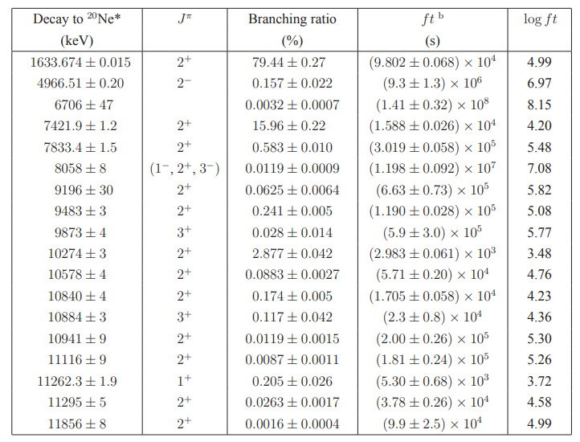

a Nuclear Physics A,493, 2, (1989), 293-322 (All values are taken from this ref)

b Allowed decays assumed

